Mach-26
Critical Design Review


Ka’an Astra
Isaac Sánchez
Category 1

Contenido
1. Introduction (1 page) 2
1.1 Mission Statement 3
1.2 Objectives 3
2. Launch Vehicle (~10 pages) 4
2.1 Launch Vehicle Overview 4
2.1.1 Modifications 4
2.2 Launch Vehicle Design and Verification 5
2.3 Flight Safety Analysis 8
2.4 Motor Selection 11
2.5 Recovery Subsystem 12
2.6 Ground Control System (GCS) Design 15
2.7 Launch Vehicle Requirements Verification Matrix 21
3. CanSat payload (~5 pages) 25
3.1 Payload Final Design 25
Overall Structural Design 25
Structural Components 28
Changes since PDR 29
Estructural integrity and vibration mitigation 30
Technical justification of manufacturing materials (3D print) 31
3.2 Descent Control 33
Parachute Sizing 34
Parachute drift modeling 35
Movement over the center of mass 36
Centers of mass 39
Forces 41
Center of Mass Movement 42
Speeds in the system 44
System of equations 45
Parameters used in the simulation 47
3.3 Electrical Power Subsystems 48
3.4 Category Challenge Integration 48
3.5 Requirements 52
4. Testing (5 pages) 54
5. Safety Management (3 pages) 58
5.1 Safety Compliance 58
5.2 Risks and Mitigation 60
6.Project Management (3 pages) 63
6.1 Schedule 63
6.2 Budget 63
7. Conclusion (>1 page) 64
8. Acknowledgements 64

1. Introduction (1 page)

1.1 Mission Statement
Describe any changes to your mission statement since the PDR.
Since the Preliminary Design Review (PDR), the mission statement has been refined to improve clarity and a better reflect of the technical objectives of the project.

To design, build, and successfully launch a model rocket capable of reaching a target apogee of 450 meters, carrying a camera-equipped CanSat to capture and store continuous in-flight video, while safely transporting and recovering a fragile extra payload (quail egg) besides the CanSat. This mission aims to demonstrate reliable payload and rocket integration, data acquisition, payload protection, and recovery under real flight conditions, in full compliance with the UKRA Model Rocket Safety Code.

1.2 Objectives
Give an updated list of specific objectives you want to achieve with this project, including the function of your CanSat payload since the PDR submission.
In the description, you should highlight how you have identified relevant requirements from the mission guidelines.
ID | Title | Description
OBJ-1 | Target Apogee Accuracy | The model rocket system shall reach an apogee as close as possible to 450 meters, keeping a stable flight in accordance with the UKRA Model Rocket Safety Code.
OBJ-2 | CanSat Video Acquisition During Flight | The CanSat shall be capable of recording and storing continuous video throughout the entire flight, from liftoff to recovery.
OBJ-3 | CanSat Telemetry, Tracking, and Data Storage | The CanSat shall integrate altitude and GPS sensors, also acquire, store, and provide access to flight data, including a redundant tracking capability.
OBJ-4 | Safe Transport and Recovery of Additional Payload | The payload system shall ensure the safe transport and recovery of a quail egg, keeping its structural integrity during ascent, descent, and landing, without compromising flight safety.
OBJ-5 | Controlled Descent and Recovery System | The recovery system shall limit the descent rate to safe values and ensure that both the rocket and the CanSat land within drift radius of 400 meters.
OBJ-6 | Compliance, Safety, and Verification | All rocket and CanSat subsystems shall be designed, integrated, and verified in accordance with the UKRA Model Rocket Safety Code, including structural integrity, stability margins, electrical safety, and recovery system reliability.

2. Launch Vehicle (~10 pages)

2.1 Launch Vehicle Overview
Provide a summary of the vehicle design (1 sentence is sufficient).

2.1.1 Modifications
Describe any changes to the components since the PPDR. List each component that was changed and which components remain the same in your final design. Describe how these changes impact the budget and timeline.
Detailed Modifications and Component Evolution
Following the Preliminary Design Review (PDR), the M.I.L.A.N.E.S.O. launch vehicle underwent a comprehensive structural and mass-property optimisation phase. This iterative process was driven by the requirement to increase the safety factor of the aerodynamic surfaces and to refine the stability margin. The final configuration achieved a mass reduction of 51 g, resulting in a launch-ready mass of 1091 g.
- Redesigned Components
- Primary Aerodynamic Surfaces (Fins): The initial proposal of solid cedar wood was rejected due to its inherent orthotropic limitations and low shear modulus across the grain. The fins have been re-engineered as Custom Quasi-Isotropic Cedar Laminates.
Technical Specification: Each fin is composed of multiple cedar veneers, with the grain orientation of adjacent layers offset by 90 degrees. This creates a balanced laminate that exhibits uniform mechanical properties in the longitudinal and transverse axes.
Manufacturing Process: The veneers are bonded using a high-viscosity, structural-grade epoxy resin. The assembly is subjected to a uniform compression cycle using a precision mechanical press and industrial G-clamps. This controlled clamping pressure ensures a minimal bond-line thickness and maximum fibre-to-matrix ratio, effectively eliminating the risk of inter-laminar delamination or aeroelastic flutter at the projected maximum velocity of 102 m/s.

Ogive Recovery System Interface (Nosecone): The nosecone architecture was transitioned from an ambiguous "solid infill" model to a High-Density Shell Membrane design.
- Technical Specification: Manufactured via Fused Deposition Modelling (FDM) in Polyethylene Terephthalate Glycol (PETG), the component features a 5.0 mm perimeter wall thickness.
- Engineering Justification: This 5.0 mm "solid shell" provides the necessary hoop strength to resist stagnation pressure and skin friction heating at Max-Q. By maintaining a hollow core, the component mass was fixed at 180 g, allowing for precise ballast control. This ensures the Centre of Gravity (CG) remains at 38.1 cm, providing a stable margin of 1.84 calibres.
B. Retained Components
The following subsystems were validated during the PDR and remain unchanged in the final flight configuration:
- Airframe Structure: The 3-inch diameter spiral-wound Kraft glassine body tube was retained due to its excellent strength-to-weight ratio and proven resistance to buckling under the 102 N peak thrust.
- Propulsion Module: The Aerotech G80T-7 (Single Use) remains the primary motor, providing the necessary impulse to achieve a safe off-rail velocity of 13.1 m/s.
- Recovery Hardware: The Top Flight Recovery PAR-18 (18-inch) ripstop nylon parachute and the 12-strand Kevlar shock cord remain the baseline for the recovery sequence.
C. Strategic Impact on Budget and Timeline
- Financial Optimisation: The transition to in-house cedar lamination represents a strategic cost-saving measure. By utilising raw timber veneers and structural epoxy already available in the laboratory, the team avoided the significant lead times and high procurement costs of imported aerospace-grade G10 fibreglass or birch plywood.
- Work Breakdown Structure (WBS) Impact: The custom lamination process introduced a specific 24-hour isothermal curing window into the manufacturing timeline.

2.2 Launch Vehicle Design and Verification
Complete Design with Justifications
Include CAD drawings (or other form of drawing) and annotations of your detailed design. Include necessary parts, such as seen in the list below, with the level of detail proportional to the specific part.
- Nose Cone
- Transition Piece (if applicable)
- Fins, Boat Tail
- Motor Tube
- Motor Retainer
- Airframe Tubing
- Couper Tubing
- Launch Lugs/ Buttons
- Bulkheads
- Centering Rings
- Electronics / Avionics
Integrity of Design
Please detail and justify the following in as many pages as necessary:
- Fin Shape and Size
- Materials for Fins, Bulkhead and Airframe Tubing
- Motor Mounting and Retention
- Mass Estimates

[Insert Figure X: M.I.L.A.N.E.S.O. Full Assembly CAD with Annotations]
flechas señalando "Motor Retainer", "Avionics Bay", "Centering Rings", etc.
2.2.1 Complete Design with Justifications
The M.I.L.A.N.E.S.O. launch vehicle is engineered as a single-stage, unguided suborbital rocket optimised for the Mach-26 450 m apogee target. The following details the final component architecture:
- Nose Cone: An ogive-profile aerodynamic fairing manufactured via FDM 3D printing in PETG. It features a rigidly controlled 5.0 mm perimeter wall thickness and a hollow interior. It integrates a 30 mm shoulder (64 mm outer diameter) for a secure friction fit with the primary airframe.
- Airframe Tubing: The main fuselage is constructed from 3-inch (76.2 mm OD) spiral-wound Kraft glassine tubing. This provides a highly favourable strength-to-weight ratio and maintains RF transparency for the internal telemetry module.
- Coupler Tubing: Also manufactured from Kraft glassine, functioning as the structural interface between airframe segments and housing the payload. It features a 7.44 cm OD to match the main airframe's internal diameter seamlessly.
- Fins: A three-fin configuration manufactured from custom quasi-isotropic cedar laminate (cross-grain veneered and epoxy-cured).
- Motor Tube: A 29 mm internal diameter Kraft phenolic tube designed specifically to house the Aerotech G80T-7 Single Use motor, isolating the thermal and mechanical loads from the outer airframe.
- Centering Rings: Precision-cut structural rings (wood composite) that concentrically align the 29 mm motor tube within the 76.2 mm main airframe. They transfer the 102 N peak thrust directly into the body tube walls.
- Motor Retainer: A mechanical retention system affixed to the aft centering ring. As the G80T is a single-use motor without a flanged casing, this retainer positively locks the motor in place, preventing forward penetration during thrust and rearward ejection during the black powder delay charge deployment.
- Launch Lugs / Buttons: Two standard linear rail buttons rigidly mounted to the airframe (anchored through the centering rings where possible) to interface with the nominal 2.0 m launch rail, ensuring a zero-degree angle of attack until off-rail velocity is achieved.
- Bulkheads: no colocamos bulckheads .Load-bearing structural bulkheads cap the internal compartments. The forward bulkhead acts as the primary anchor point for the 14 mm Kevlar shock cord, sealing the avionics bay against the corrosive ejection charge gases.
[Insert Figure Y: exploded CAD views or cross-sections of the Motor Mount Assembly]

2.2.2 Integrity of Design
Fin Shape and Size The fin geometry utilises a elliptical trapezoidal planform. This specific shape was selected to minimise aerodynamic drag while shifting the Centre of Pressure (CP) sufficiently aft (to 52.1 cm from the nose tip). The sizing was iteratively optimised in the 6-DOF simulation to balance the aerodynamic restoring forces against the vehicle's mass distribution, culminating in a highly stable, final static margin of 1.84 calibres. This ensures rapid dampening of any pitch or yaw moments post-rail exit without making the vehicle over-stable and susceptible to crosswind weathercocking.
Materials for Fins, Bulkheads, and Airframe Tubing Material selection strictly adhered to Mach-26 non-metallic safety regulations while maximising specific strength:
- Fins: The in-house cedar laminate effectively neutralises the orthotropic weakness of solid wood. By orienting the grain at 90-degree offsets and curing under mechanical pressure, the composite fins achieve the shear modulus required to resist aeroelastic flutter at the maximum velocity of 102 m/s.
- Airframe Tubing: Spiral-wound Kraft glassine was chosen over fibreglass to strictly maintain the mass budget. It offers exceptional longitudinal stiffness against the compressive loads generated during the 13.1 m/s rail exit and subsequent acceleration.
- Bulkheads: Engineered wood composites are utilised to bear the immense tensile loads generated during parachute deployment. When the ejection charge fires, deploying the system at 12.1 m/s, the bulkheads must transfer the kinetic energy from the 14 mm Kevlar shock cord to the airframe without shearing.
Motor Mounting and Retention The integrity of the propulsion interface is paramount. The Aerotech G80T-7 generates a peak thrust of 102 N and an average thrust of 78 N over 1.71 seconds. This force is distributed through the motor tube into the aft and forward centering rings, which are bonded to the airframe using structural epoxy fillets. This prevents stress concentrations that could cause the airframe to buckle. The mechanical aft retainer ensures the motor casing remains locked inside the vehicle throughout the entire flight profile, neutralising the risk of ejecting hazardous debris over the range.
Mass Estimates A rigorous mass management protocol was enforced following the PDR. The total lift-off mass is precisely calculated at 1091 g.
- Propulsion: The fully loaded G80T motor contributes 62.5 g.
- Forward Structure: The 5.0 mm PETG nosecone is calibrated to 170 g, providing critical forward ballast to maintain the 1.84 calibre static margin.
- Payload: The CanSat module accounts for a fixed 450 g.
- Airframe & Recovery: The remaining mass is distributed among the Kraft tubing, the custom laminate fins, the Top Flight PAR-18 parachute, and the 12-strand Kevlar tether. This optimised mass budget yields a high Thrust-to-Weight ratio of 7.29:1, driving the rapid acceleration necessary to achieve the safe 13.1 m/s off-rail velocity.

2.3 Flight Safety Analysis
Detail your flight safety analysis below. This flight safety analysis should include the following:
- Launch Day Conditions and Analysis
- Flight Analysis and Impact on Design
- Launch Vehicle Stability
Note: Use the Mach-26 Technical Guidelines for more information.
Extensive 6-DOF (Degrees of Freedom) flight simulations were conducted using OpenRocket to validate the aerodynamic stability and safety profile of the M.I.L.A.N.E.S.O. vehicle. The mass model was strictly calibrated to the final lift-off mass of 1091 g.
2.3.1 Launch Day Conditions and Analysis
Given the geographical context of the Mach-26 competition (Scotland, UK), the launch vehicle must be capable of safe operation in variable maritime/coastal atmospheric conditions, specific to the geography of the launch site. The flight model has been analysed against the strict safety limitations outlined by the UK Rocketry Association (UKRA).
Wind represents the primary operational risk, as it introduces lateral loads and deviations in the trajectory. These loads are governed by dynamic pressure: $q=\frac{1}{2}ρV^{2}$. For typical conditions in Glasgow in June ($ρ≈1.23\frac{kg}{m^{3}}$) and a maximum speed of 102 m/s: $q_{max}≈6500 Pa$.
- Wind Profile: The vehicle is cleared for launch in sustained crosswinds of up to 20 mph (approx. 9 m/s).
- Weathercocking Mitigation: To prevent the vehicle from aggressively turning into the wind (weathercocking) and breaching range safety boundaries, a high Thrust-to-Weight (T:W) ratio of 7.29:1 was engineered. Driven by the Aerotech G80T-7 motor, the vehicle achieves a calculated off-rail velocity of 13.1 m/s (assuming a nominal 2.0-metre launch rail). This velocity ensures that the custom composite fins generate immediate and dominant aerodynamic restoring forces the moment the vehicle leaves the guide rail, $F_{aero}∝V^{2}$, neutralising crosswind deflection.
2.3.2 Flight Analysis and Impact on Design
The predicted kinematic profile directly dictated several critical structural modifications to ensure the vehicle's survival and the public's safety:
- Max-Q and Aerodynamic Heating: The vehicle reaches a maximum velocity of 102 m/s (Mach 0.3) shortly after motor burnout (1.71 s). Impact on Design: This high dynamic pressure invalidated the use of standard cardboard or solid wood fins. The airframe was thus upgraded to utilise quasi-isotropic cedar laminates (Adopting a design criterion $FS≥2$) and a 5.0 mm thick PETG nosecone to prevent structural deformation or aeroelastic flutter.
- Thrust Loading: The G80T motor produces a peak thrust spike of 102 N. Impact on Design: This required the implementation of engineered wood centering rings and a mechanical aft-retainer to prevent the motor casing from penetrating the forward avionics bay or being ejected on the pad.
- Apogee and High-Energy Deployment: The predicted apogee is 476 m, which represents a highly precise ballistic trajectory relative to the 450 m target. However, simulation indicates the optimum deployment delay is 8.17 seconds, while the selected motor has a fixed 7-second delay. Consequently, the ejection charge will fire prior to apogee, deploying the parachute at a velocity of 12.1 m/s. Impact on Design: To safely dissipate the kinetic energy of this early deployment without causing a catastrophic structural failure (zippering), the recovery tether was upgraded to a high-tensile 12-strand Kevlar shock cord (14 mm width), securely anchored to reinforced internal bulkheads.
2.3.3 Launch Vehicle Stability
The M.I.L.A.N.E.S.O. demonstrates a highly robust stability profile, designed to self-correct aerodynamic disturbances instantaneously without becoming over-stable.
- Static Margin: At the moment of lift-off, the Centre of Gravity (CG) is located at 38.1 cm from the nose tip, and the Centre of Pressure (CP) is located at 52.1 cm. This geometry provides a safe static margin of 1.84 calibres, which falls perfectly within the optimal 1.5 to 2.5 range required by Mach-26 guidelines.
- Dynamic Progression: The Aerotech G80T motor contains approximately 37.5 g of solid propellant. As this propellant is consumed during the 1.71-second burn phase, the aft mass decreases, causing the CG to shift forward. As a result, the static margin progressively increases during powered flight. This dynamic shift ensures the vehicle becomes increasingly stable exactly when it experiences the highest aerodynamic forces, safely maintaining a vertical trajectory towards apogee.
    - Drift Analysis and Recovery Zone

- Drift: The horizontal displacement of the launch vehicle during the descent phase represents one of the primary flight safety constraints, as the system must remain within the maximum recovery radius of 400 m established by the mission requirements.
Is estimated as a function of wind velocity and descent time, using the selected parachute of 18" (46 cm diameter), being $V_{t}=10.2\frac{m}{s}$ and the descent time of 44 s, with height of 450 m. Wind conditions representative of Glasgow during summer were considered wind speed of 5 m/s under nominal conditions and 7 m/s under limiting conditions, resulting in a drift of 220 m for the nominal case and 308 m for the limit case. The vehicle is cleared for launch in sustained crosswinds of up to 9 m/s, but that would be the edge of the safety limit. The predicted drift remains within the allowable recovery radius of 400 m under both nominal and worst-case operational wind conditions. This indicates that the launch vehicle recovery system satisfies range safety constraints and ensures containment within the designated landing area. To ensure compliance with recovery limits, launch operations are restricted to wind speed $≤$ 7 m/s.
- Design Implications: A trade-off between descent velocity and drift was identified, increasing parachute area would reduce landing velocity but increase horizontal displacement.The selected parachute configuration prioritises containment within the recovery zone
It is important to note that this analysis corresponds exclusively to the launch vehicle recovery system. The CanSat payload employs an independent descent system, which is analysed separately.

Insert the OpenRocket "Velocity vs. Time" and "Acceleration vs. Time" graphs immediately below this section to visually prove these numbers to the evaluators).
[Insert Figure Z: Flight Kinematics - Velocity and Acceleration Curves]

2.4 Motor Selection
Outline information on motor selection and the status of motor procurement. Include any back-up plans for motor procurement.
2.4.1 Primary Motor Specification and Justification
The primary propulsion system for the M.I.L.A.N.E.S.O. launch vehicle is the Aerotech G80T-7 (Single Use).
- Performance Metrics: Peak Thrust: 102 N | Average Thrust: 78 N | Total Impulse: 133 Ns | Burn Time: 1.71 s.
- Design Justification: With the final lift-off mass of 1091 g, this motor provides a high Thrust-to-Weight (T:W) ratio of 7.29:1. This ensures a safe off-rail velocity of 13.1 m/s (on a 2.0-metre rail), giving the fins immediate aerodynamic authority and preventing weathercocking in the UK’s variable wind conditions.
- Delay Selection: The 7-second delay is the optimal commercial choice to ensure deployment occurs safely near the predicted 476 m apogee.
2.4.2 Status of Motor Procurement
The team has successfully mitigated the risks associated with international propellant transport regulations.
Procurement Status (Confirmed): As of this review, the team has established formal communication with an authorised UKRA-approved vendor (Wizards Rockets). The order for the primary Aerotech G80T-7 (Single Use) motors has been placed and confirmed.
The logistical plan for collection/delivery upon the team's arrival in the United Kingdom is already in place. This proactive procurement ensures that the flight hardware will be available for final integration and safety inspections at the launch site without delays.
2.4.3 Contingency and Back-up Plans
To ensure mission success in the event of primary motor failure or range-specific requirements, a backup plan is maintained:
- Designated Backup: Aerotech G79W-7 (Single Use).
- RSO Feedback Compliance: Strictly following the Range Safety Officer’s (RSO) PDR recommendations, the team has mandated the Single Use (SU) variant for the backup motors. This avoids the logistical complexity of proprietary aluminium reloadable casings (RMS) and ensures 100% mechanical compatibility with the vehicle's 29 mm motor mounting system under any launch-day scenario.

2.5 Recovery Subsystem
Detail your recovery system. You should include the following:
- Ejection Systems
  - Timings
  - Electronics
  - Amount of Black Power that you estimate to use
- Descent Systems
  - Description of the chutes you plan to use, including the sizing of the chutes.
  - Calculations for descent rate and drift (note the drift should be no more than 750m).
- Flight Computer
  - Description of the flight computer you plan to use.
  - Description of the flight computer’s disarming mechanism.
  - Include a description of the plan to verify your flight computer.
The recovery subsystem is designed around a passive, pyrotechnic-driven single-event deployment. At the designated delay time, the motor's ejection charge will pressurise the airframe, shearing the friction fit of the nosecone and simultaneously deploying both the Launch Vehicle's (LV) independent parachute and the CanSat payload with its own independent parachute.
1) Ejection Systems
a. Timings: The deployment relies on the internal delay grain of the COTS Aerotech G80T-7 motor. The fixed 7-second delay initiates immediately post-burnout (1.71 s). Consequently, the ejection event occurs at exactly 8.71 seconds into the flight. Simulation confirms this occurs at an altitude of approximately 465 m, at a velocity of 12.1 m/s (shortly prior to the 476 m apogee).
b. Electronics: The launch vehicle intentionally does not utilise ejection electronics or pyrotechnic altimeters. By relying on the motor's integral pyrotechnic delay charge, the system eliminates the risks associated with software deployment logic, wiring faults, or battery failure during the high-vibration ascent phase. This purely mechanical/pyrotechnic approach maximises mission assurance for the primary recovery event. This directly addresses reliability concerns raised during the PDR phase regarding system robustness
c. Amount of Black Powder Estimate: No raw black powder will be handled or estimated by the team. The ejection energy is provided entirely by the factory-sealed ejection charge integral to the Aerotech G80T single-use motor (nominally ~1.0 to 1.5 grams of standard 4FFFF propellant). This strict reliance on COTS hardware guarantees consistency and complies with maximum safety standards on the launch range. This ensures consistency and repeatability, eliminates handling risks, and complies with safety regulations.
2) Descent Systems
a. Description and Sizing of Chutes: To prevent entanglement, the Launch Vehicle and the CanSat descend on completely independent parachutes, separated dynamically by the ejection charge.
- Launch Vehicle Chute: Top Flight Recovery PAR-18. A 45.7 cm (18-inch, Area of $0.166 m^{2}$) diameter flat circular parachute manufactured from 1.7 oz ripstop nylon. It utilizes 6 shroud lines and is tethered to the airframe via a 14 mm Kevlar shock cord to withstand the 12.1 m/s opening shock. Preventing structural failure or zippering.
- CanSat Chute: A separate hexagonal parachute designed specifically for the 450 g payload. The canopy area is strictly calibrated to$0.14 m^{2}$ (assuming a nominal $C_{D}$ of 1.75) to balance safe impact energy against wind drift limitations.
b. Calculations for Descent Rate and Drift:
Drift analysis was conducted under the UKRA's maximum permitted launch wind profile of 20 mph (8.94 m/s).
- Launch Vehicle: The post-burnout airframe mass (~600 g) descending under the PAR-18 chute yields a descent rate of 12.0 m/s. Total descent time from 476 m is approximately 40-45 seconds.
- CanSat Payload: The 450 g CanSat descending under its specific chute yields a controlled descent rate of 7.0 m/s. Total descent time from 476 m is approximately 68 seconds. The CanSat mass used in OpenRocket simulations corresponds to an equivalent payload model and may differ slightly from the final integrated mass. This assumption is used exclusively for aerodynamic simulation purposes.
- Drift analysis: Using wind speed and the descent time, for worst-case when speed wind is 9 m/s, for the laun vehicle, with 44 seconds, the drift would be approximately 396 m, remaining within the safe recovery radius (~400 m). For the Cansat, with a descent time of 70 seconds, the drift would be approximately 630 m, remaining within the safe recovery radius (~750 m requirement). The system satisfies competition constraints; however, wind remains the dominant factor affecting landing dispersion.
3) Flight Computer
a. Description of the Flight Computer:
- As the primary recovery system is pyrotechnically driven by the motor, the Launch Vehicle does not house a flight computer. The Flight Computer is exclusively housed within the separate CanSat module and operates strictly as a telemetry and data-logging payload. The architecture centres on an ESP32 microcontroller, interfacing with a BMP280 barometric sensor for altitude estimation, an MPU6050 IMU for 6-DOF kinematic logging, and a LoRa E32 transceiver (configured strictly to 25 mW to comply with Ofcom IR 2030 regulations) for live ground station downlink.(REVISAR BIEN ESTA PARTE POR FA)
b. Disarming Mechanism:
- Because the Flight Computer does not control any pyrotechnic channels, a traditional pyrotechnic arming switch is not required. However, for electrical safety, the CanSat features a flush-mounted mechanical slide switch accessible from the exterior of the payload bay. This serves as the physical disconnect between the LiPo battery and the ESP32, allowing the payload to be fully safed (powered down) while on the launch pad. The actual pyrotechnic system (the G80 motor) is disarmed via standard igniter removal. Esto No lo hemos implementado pero suena a una Buena idea pero alch es cosa que deben discutir tu Jeff (O Isaac) si leen junto con esto Gala y David pq no. Ya lo hablamos ta bien asi que se agregue eso .
c) Verification Plan
- To ensure reliability, the flight computer will undergo ground functional testing, sensor calibration, telemetry validation, vibration testing, simulated launch conditions, drop testing, validation of data logging during descent, end-to-end system testing, and full mission simulation including telemetry and recovery. This addresses previous feedback regarding insufficient validation and ensures system readiness prior to launch.
(REVISEN ESTA PARTE PORFAVOR)

2.6 Ground Control System (GCS) Design
Our Ground Control System (GCS) has been designed as a robust, redundant receiving and monitoring platform capable of acquiring telemetry from the CanSat in real time, processing it locally, storing it persistently, and making it available remotely via a web dashboard. The diagram of the ground station is shown below.
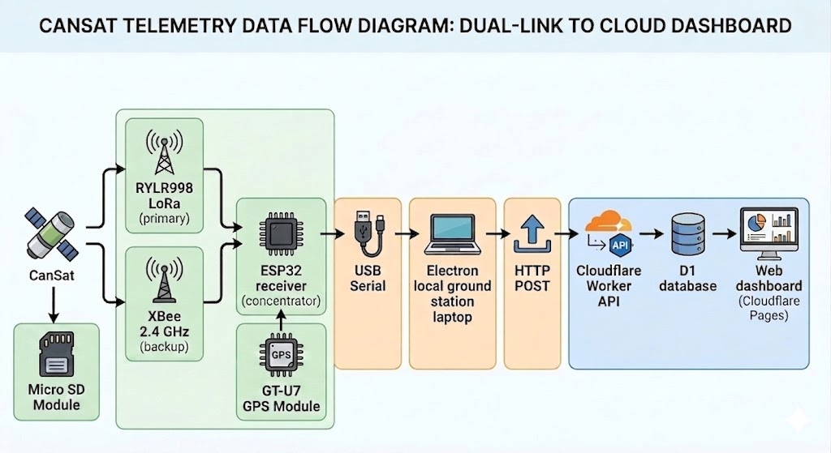
The receiving side consists of:
- Two radio modules on the CanSat (RYLR998 LoRa and XB3-24AUT-J XBee) that transmit independently.
- On the ground, an ESP32 microcontroller acts as a radio concentrator where it receives packets from both LoRa and XBee modules through UART serial communication and forwards all data through a single USB serial port to the laptop running the ground station software.
- The local ground station is an Electron desktop application that parses, processes, displays and forwards the telemetry.
- Finally, the Electron app sends the normalised data asynchronously via HTTP to a Cloudflare Worker, which stores it in a Cloudflare D1 SQLite database and serves it to the web dashboard.
- Additionally, within the CanSat payload, there is an SD card module that stores data for later processing once the mission is completed.
- The ground station incorporates a GT-U7 module that allows the implementation of the real-time cargo tracking and recovery system.
a) Primary communication interface
The primary communication link is based on IR2030/1/19 interface from IR 2030 – UK Interface Requirements 2030, where it establishes a frequency band of 869.40 - 869.65 MHz, a maximum transmit power of 500 mW e.r.p. and a duty cycle limit of ≤10% (Ofcom, p. 17, 2023).
For its operation, the center band of 869.5 MHz was established. Considering that the module's band accuracy ranges from ±10 ppm (REYAX, 2026, pp. 2-6), the bandwidth is reflected as 10 ppm = 8.695 kHz, resulting bandwidth between 869.491305 MHz - 869.508695 MHz ≈ 869.49-869.51 MHz.
This falls within the interface range of 869.40 – 869.65 MHz. The frequency is set by code using the following command:
lora_send_command("AT+BAND=869500000");

Additionally, there is a maximum operating power (ERP) of 500 mW, but since CE certification only applies to this device with a maximum power of 14 dBm (REYAX, 2026, pp. 2-6), this maximum limit is used. The gain of the integrated helical antenna is unknown, so it is assumed to be between + 1.5 dBi and + 2 dBi (based on similar antennas of that type).
The output power, considering an antenna gain of + 2 dBi, should reach a maximum of 14 dBm (25.12 mW), thus satisfactorily meeting the maximum transmission power requirement. The transmission power is set by code using the following command:
lora_send_command("AT+CRFOP=12");

For more precise monitoring, RF power measurement tests will be conducted using specialized equipment to adjust the LoRa module's output power, considering the compensation provided by the integrated antenna. CE certification compliance is a primary objective for the team, but if necessary, it can be waived to increase transmission power and ensure a stable and long-range connection, while maintaining a power margin well below the total 500 mW e.r.p.
Regarding the work cycle, the following is proposed. A set payload will be sent with the 14 variables of the CanSat sensors, declared in types int16_t (2 bytes) and int32_t (4 bytes), and according to the length and precision with which it is required to work, there is a total of 32 bytes to send.
typedef struct {
uint16_t pressure;
int16_t temperature;
int16_t accel[3];
int16_t gyro[3];
int16_t mag[3];
int16_t altitude;
int32_t latitude;
int32_t longitude;
} cansat_t;

Using the parameters for a binary payload with a maximum size of 53 bytes, an SF9, a bandwidth of 125 kHz, and a DR of 1 are obtained (Semtech, 2024, p. 11). For defining these parameters within the command lines, the manufacturer's conventions are used: 9 for the SF9 spreading factor, 7 for the bandwidth of 125 kHz, 1 for a default coding rate of 4/5, and an additional preamble variable with a default value of 12 (REYAX, 2021, p. 5). To adjust the radio frequency power, the following command is used (REYAX, 2021, p. 5):
AT+PARAMETER=<Spreading Factor>, <Bandwidth>, <Coding Rate>, <Preamble>
Adjusted in the code, it is implemented on the following line:
lora_send_command("AT+PARAMETER=9,7,1,12");

To obtain a duty cycle ≤10%, the time rate $(T_{s})$ must first be obtained using the symbol rate $(R_{s})$ from the following formula (Semtech, 2015, p. 28-31).
$$T_{s}=\frac{1}{R_{s}} ; R_{s}=\frac{BW}{2^{SF}}$$
Substituting, we obtain:
$$T_{s}=\frac{1}{\frac{125 kHz}{2^{9}}}=4.096 ms$$
The packet's duration in the air is the sum of the time rate and the preamble time $\left(T_{preamble}\right)$. The formula for preamble time is as follows (Semtech, 2015, p. 31).
$$T_{preamble}=\left(n_{preamble}+4.25\right)T_{s}$$

Substituting the values ​​into the formula:
$$T_{preamble}=\left(12+4.25\right)4.096 ms=66.56 ms$$

The payload duration $(T_{payload})$ is the number of symbols in the payload $(n_{payload})$ multiplied by the time rate, as expressed in the following formula (Semtech, 2015, p. 31):
$$T_{payload}=n_{payload}×T_{s}$$

The number of symbols in the payload $(n_{payload})$ is obtained from the following formula (Semtech, 2015, p. 31):
$$n_{payload}=8+\left(\frac{8PL-4SF+28+16CRC-20IH}{4\left(SF-2DE\right)}\right)\left(CR+4\right)$$

where:
- PL is the number of payload bytes (from 1 to 255)
- SF is the spread factor (from 6 to 12)
- IH = 0 when the header is enabled, IH = 1 when no header is present
- DE = 1 when LowDataRateOptimize = 1, DE = 0 otherwise
- CR is the encoding rate (1 corresponds to 4/5, from 4 to 4/8)

Substituting, we obtain the following number of payload symbols:

$$n_{payload}=8+\left(\frac{8\left(32\right)-4\left(9\right)+28+16\left(1\right)-20\left(0\right)}{4\left(9-2\left(0\right)\right)}\right)\left(1+4\right)=44.66≈45$$

Therefore, the payload duration is:

$$T_{payload}=45×4.096 ms=184.32 ms$$

Finally, from the payload duration and the preamble time, we obtain the on-air time (Semtech, 2015, p. 31):

$$T_{on-air}=T_{preamble}+T_{payload}$$

Substituting, we obtain that the on-air time $(T_{on-air})$ is:

$$T_{on-air}=66.56 ms+184.32 ms=250.88 ms≈251 ms$$

With a Given an on-air time of 251 ms, the transmission period required to achieve a duty cycle of less than 10% is calculated.

$$Duty cycle(\%)=\frac{T_{on-air}}{T_{period}}×100$$
$$T_{period}=\frac{T_{on-air}}{Duty cycle(\%)}×100$$

Substituting the values, we obtain $T_{period}$:

$$T_{period}=\frac{0.251 s}{10}×100=2.51 s$$

To achieve a 10% duty cycle, the payload must be transmitted for a minimum of 2.51 s. Setting the parameter to 3 seconds, we get a duty cycle of:

$$Duty cycle\left(\%\right)=\frac{0.251 s}{3 s}×100=8.3666\%≈8.37\%$$

The duty cycle would be 8.37%, satisfactorily meeting the maximum margin of 10%. In the code, the line responsible for defining the payload sending time is the following:

vTaskDelay(pdMS_TO_TICKS(3000));

This function is located within the while loop (1), so it executes continuously every 3 seconds after the last data transmission, ensuring that the system properly fulfills the duty cycle.

NOTE: These duty cycle adjustment parameters are provisional, as they are still in experimental stages to achieve a longer payload transmission time during operation (shorter time between transmissions). In any case, the above serves as a declaration that a fully functional and current standard for the IR2030/1/19 interface parameters has been defined.

b) Secondary communication interface
The secondary communication link is based on IR2030/1/22 interface from IR 2030 – UK Interface Requirements 2030, where it establishes a frequency band of 2400 – 2483.5 MHz and a maximum transmit power of 10 mW e.i.r.p. (Ofcom, p. 22, 2023).

The center band frequency is set by sending an AT command from the microcontroller to the XBee module. Each command begins with AT followed by two letters representing the command to be configured, space, and the parameter in HEX format (Digi, 2023, p. 87).

According to the Digi XBee 3 ZigBee documentation (2023), the parameters for configuring the frequency band (CH) are set using its HEX commands (p. 250). It was decided to work with the 2.410 GHz frequency, therefore the appropriate channel to implement is 0C (p. 250). The resulting AT command is:
ATCH 0C

In the code it is implemented as follows:
send_cmd("ATCH 0C");

Similar to bandwidth, this command is configured using the transmission power (PL) and an integer parameter that determines the decibel level (Digi, 2023, pp. 249-250).
For 8 dBm (approximately 6.31 mW), parameter 4 is used (Digi, 2023, pp. 249-250), resulting in the following AT command:
ATPL 4

In the code, it is implemented as follows:
send_cmd("ATPL 4");

Regarding the antenna, this model has a U.FL connector, which allows for the use of an antenna with a gain of +1.5 dBi to +2 dBi to achieve the 10 mW (10 dBm) limit imposed by the interface. The ANTX100P001B24003 (PCB antenna) and a reverse-polarization dipole antenna, both with a gain of 2 dBi, are suggested. The final choice will depend on which option provides a stable telemetry connection over the longest distance.

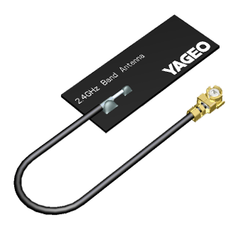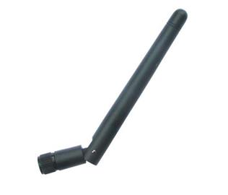

There are no restrictions of any kind for this communication interface regarding duty cycles; however, the same 3-second delay will be applied to payload transmission using the LoRa protocol in order to standardize the data transmission process. This is subject to change based on potential considerations in future testing.

In terms of operating time, the ground station is expected to function for the full launch window using portable battery power. The radio receivers have relatively low power demand, while the laptop can typically operate for several hours on its internal battery. Under nominal operation, the complete GCS is expected to remain functional to remain functional for at least 3 to 5 hours, which is sufficient for pre-launch checks, flight operations, and immediate post-landing recovery. As an additional safety measure, an external power bank will be available to extend laptop and receiver operation if delays occur. Therefore, no fixed external power source is required, although portable backup power is recommended.
How will telemetry be displayed in real time? How will it be recorded? Do you need a license to transmit on these frequencies? Will the GCS work in Machrihanish wind and rain?
Telemetry will be displayed in real time on a laptop-based interface connected to the ground receivers through serial communication. The interface will show the most relevant flight parameters, including altitude, GPS position, temperature, pressure, and mission status flags. In addition to real-time visualisation, all received telemetry packets will be automatically recorded on the ground station laptop in CSV or text-log format for post-flight analysis. This ground logging is complemented by onboard SD card data storage to ensure data recovery even if radio communication is temporarily lost. Furthermore, as an emergency measure, we have a web-based ground station, where the physical ground station sends data to an API designed to receive and display the data online.
No licenses are required to transmit on these frequencies. All transmissions operate under the UK Interface Requirement IR2030 for non-specific short-range devices (airborne permitted). On the contrary, the module manufacturers offer certification guarantees:
  - RYLR998: CE RED (UE), under 14 dBm operation (REYAX, 2026, pp. 2-6).
  - XB3-24AUT-J: CE (UE) and UKCA (United Kingdom) (Digi, 2026).
To ensure operation in Machrihanish environmental conditions, the GCS will be prepared for wind and light rain exposure. The laptop and receivers will be placed inside protective enclosures or covered operating stations, and antennas will be mounted securely to prevent loss of alignment or mechanical instability in strong wind. Waterproof covers, cable strain relief, and weather-protected electronics housings will be used to reduce the risk of rain-related failures. These measures are intended to maintain telemetry reception reliability under the expected field conditions.

2.7 Launch Vehicle Requirements Verification Matrix
List out your requirements for the launch vehicle. We have provided some guidance on how to categorise your requirements for the launch vehicle below. Verification methods can be categorised in the following way. Pick which verification method is best suited for each requirement. You will be able to elaborate further in your Test Plan (Section XX)
Categories for verification are:
- Test: Verification by testing under specific conditions, often using test environments and specific equipment.
- Analysis: Verification by modelling, calculations or simulations.
- Inspection: Verification by looking at something.
- Demonstration: Verification by showing that the final product does what it’s supposed to do. Is qualitative rather than quantitative (which testing is) and less rigorous and data gathering heavy compared to testing.
We recommend looking at the Mach-26 Guidelines document. A few of the requirements can be extracted from the guidelines.

Functional Requirements describe how components should function to achieve the mission objectives.
ID | Description | Justification | Verification Method
FUN- 1 | The vehicle must reliably separate and deploy independent recovery systems for the airframe and CanSat. | Ensures safe deceleration and completely prevents entanglement between the two descending masses. | Demonstration & Test (Ground-based ejection test)
FUN -2 | The vehicle must positively retain the primary motor throughout the entire flight profile. | Prevents the 102 N peak thrust from driving the motor forward into the avionics, and prevents rearward ejection during the delay charge. | Inspection & Demonstration (Mechanical fit check)

Performance Requirements define how well a system performs. These requirements define what is ‘good enough’.
ID | Description | Justification | Verification Method
PER-1 | The vehicle must achieve an off-rail velocity of at least 13.0 m/s upon leaving a 2.0 m guide rail. | Ensures sufficient aerodynamic authority for the fins to prevent weathercocking in up to 20 mph crosswinds. | Analysis (6-DOF OpenRocket Simulation)
PER-2 | The descent drift of all vehicle components must not exceed 750 m under maximum permitted wind conditions. | Strict adherence to Mach-26 range safety limitations and UKRA guidelines for a 476 m apogee. | Analysis (Kinematic descent calculation)
PER- 3 | The airframe and CanSat must land with a descent velocity not exceeding 12.0 m/s and 7.0 m/s respectively. | Minimises kinetic energy upon impact to protect onboard electronics and prevent hazardous debris. | Analysis (Aerodynamic drag mathematical modelling)
PER-4 | The vehicle must reach an apogee within ±10% of the 450 m target. | Ensures mission performance accuracy. | Analysis (OpenRocket simulation)

Design Requirements define what the launch vehicle should look like.
ID | Description | Justification | Verification Method
DES-1 | The launch vehicle must withstand aerodynamic forces during ascent. | The nosecone is designed with a 5.0 mm solid PETG wall thickness, preventing deformation under stagnation pressure. | Analysis (OpenRocket mass/density calculation) & Inspection
DES-2 | The primary airframe and all aerodynamic surfaces must be constructed exclusively from non-metallic materials. | Mandatory Mach-26 safety rule to minimise hazard severity in the event of a ballistic trajectory or impact. | Inspection (Visual material validation)
DES-3 | The fins must possess sufficient shear modulus to withstand aeroelastic flutter at a peak velocity of 102 m/s. | The fins utilise an in-house, cross-grain quasi-isotropic cedar laminate cured under uniform mechanical pressure. | Analysis & Test (3-point bend stress test)
DES-4 | The nosecone must have a minimum wall thickness of 5 mm PETG. | Prevents deformation under aerodynamic pressure. | Inspection

Interface Requirements define how components and systems are expected to connect and interact with one another.
ID | Description | Justification | Verification Method
INT-1 | The nosecone shoulder must maintain a friction fit during ascent but shear reliably under pyrotechnic pressurisation. | Prevents premature drag-separation during the 1.71 s motor burn while ensuring the parachutes deploy at the 8.71 s mark. | Test (Shear pin / Friction fit ground test)
INT-2 | The airframe must interface seamlessly with a standard competition launch rail. | Ensures a zero-degree angle of attack until safe off-rail velocity is achieved. | Demonstration (Rail button sliding fit)
INT-3 | The 14 mm Kevlar shock cord must interface securely with the primary airframe bulkheads without shearing the Kraft tubing. | The Kevlar must absorb the kinetic energy of the early 12.1 m/s parachute deployment. | Analysis & Inspection (Tensile load calculation)

Operational Requirements define what team members are required to do to ensure the launch vehicle is operational.
ID | Description | Justification | Verification Method
OP-1 | The CanSat avionics must feature an external mechanical switch to be safed or armed while on the launch pad. | Protects range personnel from electrical hazards and preserves battery life during pre-launch range delays. | Demonstration
OP-2 | The Ground Control Station (GCS) must operate continuously on battery power for the duration of the launch window. | Ensures telemetry recording is not interrupted during extended 3-to-5-hour pad delays without relying on mains power | Test (Battery longevity run)

If there are any, include additional requirements that couldn't be placed in the categories as above.
ID | Description | Justification | Verification Method
ADD-1 | RF Transmission must strictly comply with UK Ofcom IR 2030 regulations for Short Range Devices (SRD) | Legal requirement. The LoRa module is software-attenuated to ≤ 25 mW within the 868 MHz band. | Inspection (Firmware code review)
ADD-2 | Solid rocket motors must be legally procured within the UK. | International aviation law prohibits transporting propellants from Mexico. Motors are sourced via UKRA-approved vendors. | Inspection (Purchase order validation)

3. CanSat payload (~5 pages)

3.1 Payload Final Design
In as many pages as necessary, show the structure and materials of your CanSat (e.g. CAD model) in a dimensioned, annotated diagram and detail any changes made since the PDR.
Include detail on deployment/ejection subsystems.

Overall Structural Design
The final CanSat structure consists of a main cylindrical enclosure with an outer protective shell that covers and secures all internal components, as shown in Fig. X. The system has an overall height of 18 cm and a maximum diameter of 7 cm, corresponding to the external cylindrical housing. This outer shell provides mechanical protection to the payload during handling, launch, deployment, and descent, while also defining the main geometric limits of the CanSat.
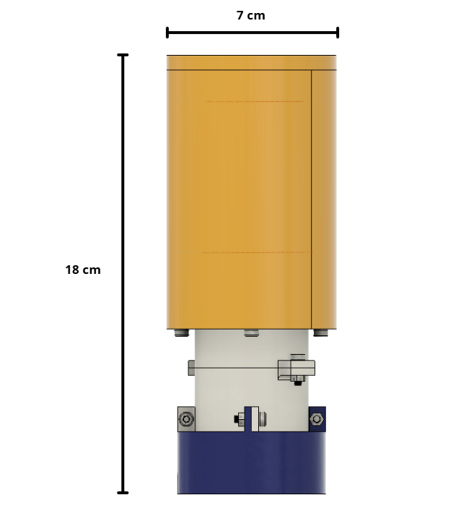
Fig X. Front view of the CanSat with overall dimensions
The internal architecture is organized vertically to maximize space efficiency and maintain stable component positioning, as illustrated in Fig. W. The electronics are mounted inside the upper section of the structure, while the battery is placed in a dedicated lower space to optimize the distribution of mass and improve assembly accessibility. The egg module is located in the central region of the system, where it is mechanically supported and isolated from direct external impact. This arrangement ensures that each subsystem has a specific location within the structure, reducing interference between components and improving overall functionality.
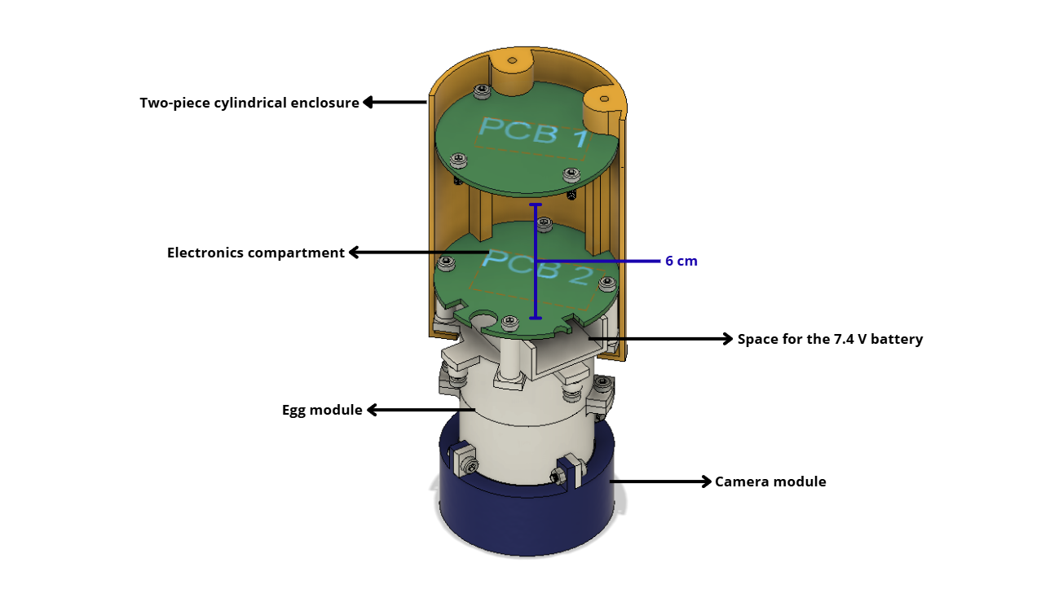
Fig W. Internal structural layout of the CanSat showing PCB arrangement

At the bottom of the CanSat, the camera module is integrated with a downward-facing camera aperture, allowing the camera to record the lower side of the vehicle during descent, as shown in Fig. Z. This configuration ensures unobstructed visual data acquisition while maintaining structural integrity in the lower section.
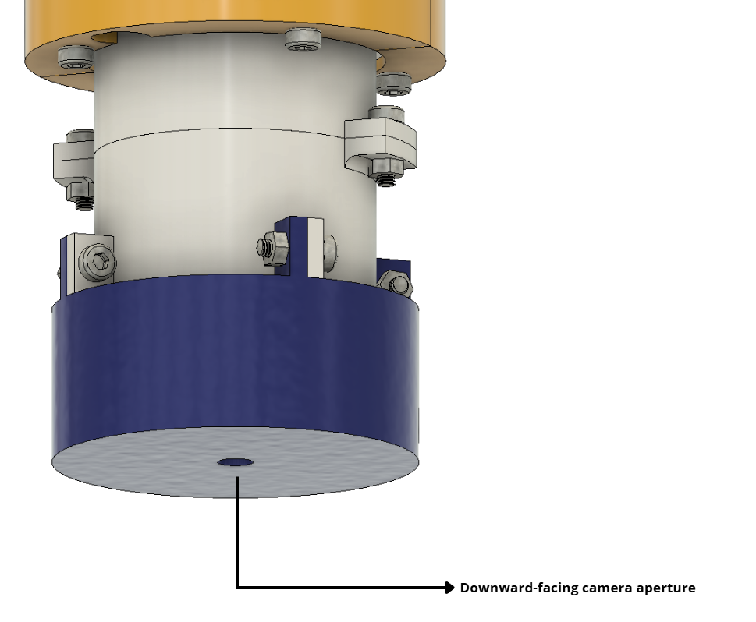
Fig Z. Bottom view showing the downward-facing camera aperture

The enclosure is assembled using M3 screws and, in selected locations, nuts, which provide a secure and repeatable mechanical connection between the different structural parts. This fastening method allows the CanSat to remain rigid during flight while also enabling disassembly for maintenance, inspection, and testing.
In addition, the top section includes a parachute attachment point integrated into the top end cap, which is essential for a reliable deployment subsystem, as shown in Fig. Q. This attachment point ensures that the parachute can be firmly connected to the CanSat and that the ejection and descent phases occur in a controlled and stable manner.
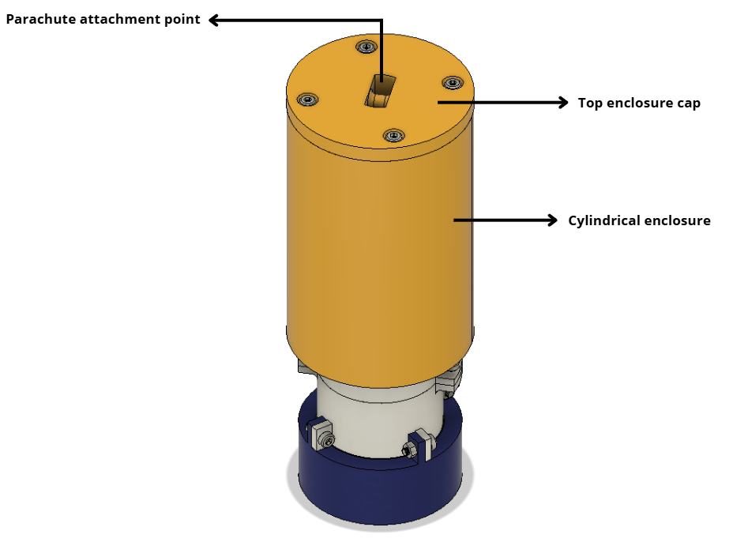
Fig Q. External view of the cylindrical enclosure and top end cap

Structural Components

The structural design of the CanSat consists of a reduced yet efficient set of components that ensure mechanical integrity while maintaining a lightweight and compact configuration.
The primary structural element is the cylindrical enclosure, which functions as the main load-bearing structure and provides protection for all internal subsystems. Its geometry allows for an efficient distribution of mechanical stresses during launch, ejection, and descent.
The top end cap serves as the upper closure of the system and incorporates the parachute attachment point, enabling the transmission of forces generated during parachute deployment. This component plays a critical role in maintaining structural stability throughout the descent phase.
At the lower end, the bottom section provides structural closure while integrating a downward-facing camera aperture, allowing sensor operation without compromising the rigidity of the enclosure.
In addition to the external structure, the enclosure integrates internal support columns (standoffs) that are directly incorporated into the body of the structure. These elements are used to mechanically support and fix the PCBs in position. The upper PCB is mounted onto these columns using M3 screws, while additional columns are positioned on top of the egg module to support the lower PCB. This configuration ensures proper alignment, prevents unwanted movement, and contributes to the overall structural stability of the system. The arrangement of these internal supports and their interaction with the PCBs is illustrated in Fig. E.
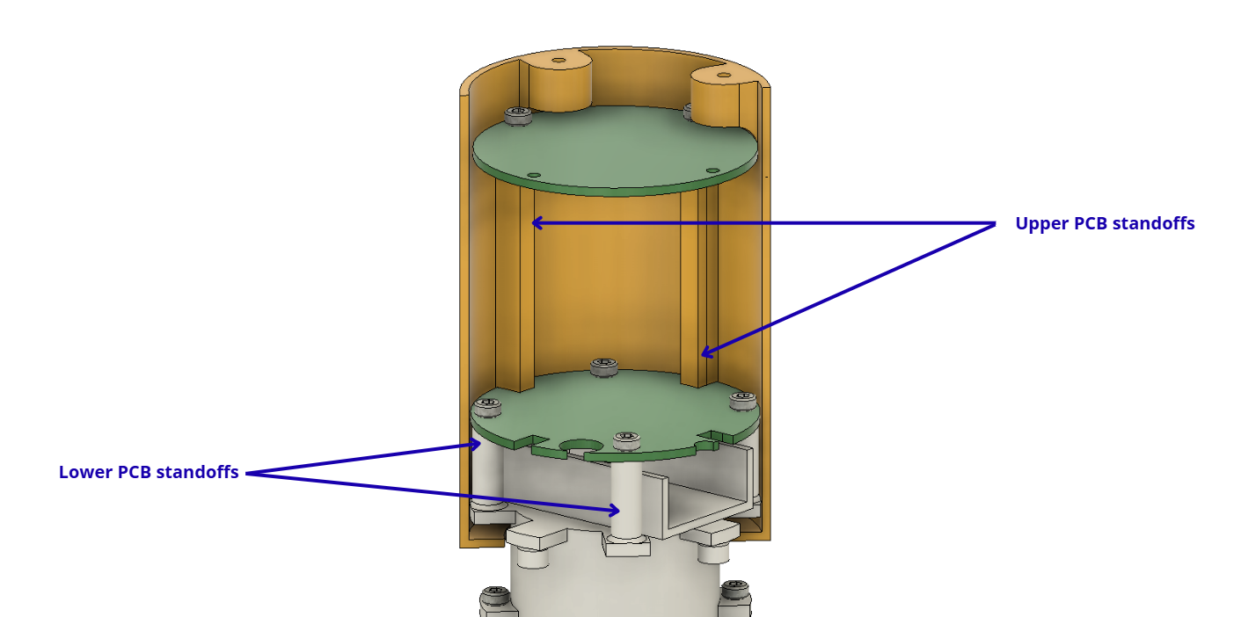
Fig E. Standoff configuration for mounting the upper and lower PCBs

All structural elements are assembled using a fastening system based on M3 screws and nuts, which provides a secure and reliable mechanical connection. This system ensures sufficient rigidity to withstand expected mechanical loads while also allowing straightforward assembly, disassembly, and maintenance operations.

Changes since PDR

Several modifications were implemented in the final design of the CanSat to improve environmental protection, structural integrity, and overall system reliability compared to the Preliminary Design Review (PDR).
In the initial design, the cylindrical enclosure included multiple lateral openings and perforations, particularly in the lower section and along the side walls. Additionally, the upper section of the CanSat did not incorporate a top end cap, leaving internal components partially exposed to the external environment. While this configuration allowed accessibility and reduced material usage, it introduced potential risks related to environmental exposure and mechanical vulnerability.
In the final design, these openings were eliminated, resulting in a fully enclosed cylindrical structure. The enclosure now incorporates a top end cap, as shown in Fig. Q, effectively sealing the upper section that contains the main electronics. This modification was implemented to protect sensitive components from external factors such as moisture, dust, and potential contaminants, which are particularly relevant given the expected environmental conditions during launch operations.
Similarly, the lower section of the CanSat was redesigned. In the PDR configuration, this region included perforations and served as a housing for an additional PCB. In the final design, the number of PCBs was reduced from three to two, simplifying the internal architecture and improving space efficiency. As a result, the lower module was repurposed into a dedicated camera compartment, now featuring a downward-facing camera aperture (see Fig. Z). This aperture is minimized to the required size and is effectively sealed by the camera lens itself, preserving the protective integrity of the enclosure.
Another significant modification involves the relocation of the battery. In the PDR design, the battery was positioned below the egg module, directly above the third PCB. In the final configuration, the battery was moved to a position above the egg module. This change was implemented to improve the mass distribution of the system and contribute to a more balanced internal layout. By relocating the battery, the design reduces potential interference with lower subsystems and improves accessibility during assembly.
These changes collectively enhance the robustness of the structure by minimizing direct exposure of internal components to the external environment. The fully enclosed configuration reduces the risk of damage due to impact during landing and prevents the ingress of water or debris, which is critical for both electronic reliability and battery safety.
Overall, the transition from a partially open design to a sealed enclosure, along with the optimization of internal component distribution, represents a significant improvement in terms of mechanical protection, environmental resistance, and system reliability, while maintaining the functional requirements of the CanSat mission.

Estructural integrity and vibration mitigation

One of the main considerations in the structural design of the CanSat is the potential loosening of threaded fasteners due to vibrations experienced during launch and ejection. Since the assembly relies on M3 screws and nuts to secure both the external enclosure and internal components, maintaining the integrity of these connections is critical.
The CanSat structure is based on a two-piece cylindrical enclosure with a top end cap, as shown in Fig. Q, where all structural elements are mechanically joined using threaded fasteners. Vibrational loads generated during launch could induce relative motion between components, potentially leading to gradual loosening if not properly addressed.
To mitigate this risk, all fasteners are securely tightened, and in critical joints, nuts are used in combination with screws to increase resistance against vibration-induced loosening. In addition, the compact geometry of the structure (18 cm height and 7 cm diameter) reduces the magnitude of inertial forces acting on the system, contributing to overall mechanical stability.
Furthermore, internal components are not solely dependent on fasteners for stability. As illustrated in Fig. E, the enclosure integrates internal support columns (standoffs) that provide direct mechanical support for the PCBs. The upper PCB is fixed onto these standoffs using M3 screws, while the lower PCB is also constrained by dedicated mounting points. This configuration prevents relative displacement between components and reduces mechanical stress on the fasteners.
In addition to the design measures described above, the assembled CanSat will be subjected to controlled vibration testing using a dedicated vibration system available to the team. This testing phase is intended to evaluate the mechanical stability of the fully assembled structure under simulated vibration conditions. The objective is to identify any potential weaknesses, such as fastener loosening or structural instability, and implement corrective actions if necessary prior to launch.
Through the combination of a robust fastening strategy and planned experimental validation, the system is expected to maintain its structural integrity under operational conditions, minimizing the risk of mechanical failure during flight.

Technical justification of manufacturing materials (3D print)
The operating environment of a CanSat inside a rocket imposes three main mechanical challenges: axial acceleration during launch, harmonic vibration from the motor, and the opening shock of the parachute deployment. The materials considered are: Sunlu Nylon PA12-CF, Bambu Lab Polycarbonate (PC), and SainSmart Nylon PA6-CF.
Table # (Poner el número de table correspondiente xd desconozco si faltan) analyzes the data extracted from the manufacturers' Technical Data Sheets (except for the SainSmart PA6-CF, where values are nominal approximations for the material type):
Propety | PA12-CF (Sunlu) | PC (Bambu Lab) | PA6-CF (SainSmart)
Density $(g/cm^{3})$ | 1.04 | 1.20 | ≈1.15
Tensile Strength (X-Y) (X-Y) (MPa) | 100 MPa | 62±2 MPa | ≈110
Flexural Modulus (X-Y) (MPa) | 5996 | 2310±70 | ≈5500
Elongation at Break (X-Y) (%) | 12% | 3.8±0.3% | ≈4%
Impact Strength (X-Y) $(kJ/m^{2})$ | 13 | 34.8±2.1 | ≈10
Heat Deflection Temp (°C) | 176 °C | 112 °C | ≈160 °C
Table #: Material Comparasion (PA12 vs PC vs PA6)
A. Launch Phase
During ascent, the structure must be rigid enough to avoid entering into resonance with the rocket's vibrations.
- PA12-CF: Possesses the highest flexural modulus, ensuring superior structural stiffness. This minimizes the deflection of the CanSat walls, protecting internal sensors from potential mechanical contact.
- PC: Having a much lower modulus of elasticity, it is a more flexible material, which could allow for higher amplitude vibrations if the wall design is thin—a common trade-off to reduce weight.
B. Ejection and Deployment Phase
Now the parachute deploys, the structure experiences a sudden snatch load or jolt.
- PA12-CF: Features an elongation at break of 12%, which is significantly higher than the 3.8% of the Polycarbonate. This indicates that PA12-CF can deform slightly in an elastic or plastic manner before failure, better absorbing the energy from the parachute deployment.
- PC: Its impact strength is the highest, making it more reliable against brittle fractures from sharp impacts during the descent or landing.
C. Moisture and Weight
PA12-CF is 12.7% lighter than Polycarbonate and 9% lighter than PA6-CF. In a CanSat, this weight saving directly translates into a lower descent rate or the ability to add more payload (sensors/passenger). Furthermore, PA6-CF tends to absorb moisture quickly (hygroscopic), which can compromise the dimensional stability of the part or soften it in humid climates. PA12-CF has much lower water absorption, ensuring that the deployment system's tolerance remains constant throughout its operation.
Material’s Justification
- PA12-CF (Sunlu): Primary Option. This material is chosen for its excellent strength-to-weight ratio. It is the only material offering 100 MPa of strength with the lowest density in comparison (1.04 $g/cm^{3}$). Its high thermal resistance (176 °C) ensures no deformation will occur even if the rocket experiences significant aerodynamic heating. Carbon Fiber reinforcement is a critical factor in this selection; it serves to significantly increase the material's stiffness and provides the dimensional stability necessary to prevent the warping and shrinkage inherent to pure polyamides.
- PC (Bambu Lab): Selection for Fastening Components. Recommended exclusively for parachute anchorage points. It’s extremely tough nature and high impact resistance perform better at preventing bolts from "tearing" out of the structure during parachute opening.
- PA6-CF (SainSmart): While PA6-CF filament possesses high-performance mechanical properties suitable for functional parts and prototypes, it is considered technically inferior to the specialized alternatives due to its higher density and marked hygroscopy compared to PA12-CF, as well as its lower impact resistance compared to PC. However, its inclusion in the design is justified by its immediate availability in the team's inventory, allowing for mechanical validation and fit testing to proceed without additional costs; despite being outperformed in lightness and toughness, its structural characteristics remain robust for the project's development phases.

3.2 Descent Control
For the preliminary parachute design, the drag force expression is taken as the starting point:
$$D=\frac{1}{2}​ρC_{D}​Av^{2}$$
where:
- D = drag force (N)
- $C_{D}$ = drag coefficient
- ρ = air density (kg/m³)
- $A$ = cross-sectional area (m²)
- $v$ = velocity of the free-falling object (m/s)
If the drag force is assumed to balance the system weight and, based on the literature, a drag coefficient value for an ideal parachute is adopted, then the quantity of interest is the required cross-sectional area needed to cushion the landing:
$$A=\frac{2D}{ρC_{D}​v^{2}}​.$$
There are different parachute configurations; among the most representative are circular models and Ram-Air types. The latter, since they are composed of inflatable cells that operate as an aerodynamic wing, provide directional control and horizontal displacement. However, they require greater technical complexity, are more sensitive to partial collapse, and are more expensive, making them less suitable for rigid, uncontrolled payloads such as a CanSat. In contrast, circular parachutes stand out for their simpler construction, lower probability of deployment failure, and more constant descent rate. In addition, the incorporation of a central vent helps reduce oscillations and improve aerodynamic stability, which are fundamental qualities for preserving system integrity and ensuring proper data acquisition during the mission. The parachute is stored folded over the CanSat, inside the rocket's undocking compartment, with the suspension lines arranged in a way that minimizes the risk of entanglement during deployment. Such deployment is expected to occur passively, aided by the free-fall condition to which the system will be exposed once released.
The drag coefficient used in the parachute sizing is 1.75, a value obtained from sources available online for similar configurations. This value is suitable for a preliminary estimate, but importantly, it can vary depending on environmental conditions, such as air density, wind speed, and the characteristics of the parachute material.

Parachute Sizing
The required front surface area was calculated from the drag force equation:
$$A=\frac{2D}{ρC_{D}v^{2}}.$$
Substituting the selected values:
- $D=3.5\text{ N}$,
- $C_{D}=1.75$,
- $ρ=1.2 {\text{kg/m}}^{3}$,
- $v=3.5\text{ m/s}$,
You get:
$$A=\frac{2×3.5}{1.2×1.75×{3.5}^{2}}=0.27 {\text{m}}^{2}.$$
From the balance between the drag force and the weight of the system, a transverse surface of the parachute was obtained. In this way, the parachute can be roughly modeled like a ring inscribed on a hexagon with external diameter and internal diameter of $A=0.27 {\text{m}}^{2}, D=55 \text{cm}\text{, }d=3 \text{cm}$.
For the final manufacture, a water-repellent fabric was selected whose properties limit the passage of air through the fibers of the material. This behavior increases the drag coefficient and, consequently, favors an effective decrease in the descent speed.
Once the parachute sizing criterion has been established, it is necessary to estimate how the system will behave during descent and to evaluate the accumulated horizontal displacement to the landing point.

Parachute drift modeling
Ideally, after deployment, the parachute-load system would be expected to perform a predominantly vertical descent (z axis) and with a minimal horizontal component. However, in practice the trajectory deviates due to various factors, including:
- the presence of horizontal wind in the plane $xy$
- the oscillation/pendulum of the load-lines-bell assembly,
- the geometry of the hood (which modifies the effective area $A$, drag coefficient $C_{D}$ and stability),
- and initial deployment conditions (tilt, asymmetries, disturbances).
Drift is defined as the cumulative horizontal displacement of the system during descent, measured between the deployment point and the landing point. In general, it is expressed as follows:
 | $$Δr_{xy}​=\int_{0}^{t_{f}}{v_{xy}\left(t\right)dt}​$$ | 1
where $v_{xy}\left(t\right)$ is the horizontal speed of the system in a frame fixed to the ground.
To describe the entire motion in three dimensions, it is possible to model both the translation and orientation of the system. In this approach, the following are distinguished: (i) a system of absolute axes (fixed to the environment) convenient for integrating the trajectory $r\left(t\right)$, and (ii) a system of body axes (linked to the parachute/load), useful for describing orientation by means of a composition of orthogonal rotations. This separation is practical because several aerodynamic quantities are naturally formulated in body axes, depending on the instantaneous orientation of the system and the relative flow. Consequently, aerodynamic forces are calculated in body axes and transformed into absolute axes by means of a rotation matrix $R\left(t\right)$, to finally use them in the translation equation of the center of mass:
 | $$m\ddot{r}\left(t\right)=\sum{F_{abs}\left(t\right)}$$ | 2
For practical purposes of the project, it was established that the horizontal displacement of the system should not exceed 400 m. Accordingly, the following mathematical and physical considerations are adopted:
- The aerodynamic effect of the payload is neglected due to its small size; only their weight is considered.
- Only the stationary descent phase is analyzed, since the deployment phase is of very short duration and its effect on the trajectory is negligible.
- The system is modeled as a single rigid solid.
- To verify that the total drift does not exceed 400 m, the three-dimensional model is omitted. The analysis is restricted to two dimensions in the ZX plane, assuming that the maximum displacement in this plane is representative of any radial direction in space.
To adequately describe the model, Hume and Steel group the equations into two main blocks: (i) an equation that represents the motion around the center of mass and (ii) a set of equations that describes the motion of the center of mass itself.

Movement over the center of mass
This equation is not yet following the position, but the $x\left(t\right), y\left(t\right)$ orientation of the parachute-load system. Because we interpret the system as a rigid body, the system can fall completely straight with respect to the ground or with an angle of inclination, the most likely case observed is previous throws, causing the system to oscillate.
To study this turn, it is natural to apply the kinetic momentum theorem:
 | $$\sum{​​}M_{CM}^{ext}=\frac{dL_{CM}}{dt}$$ | 3
That is:
The sum of external moments with respect to the center of mass is equal to the rate of change of angular momentum with respect to the center of mass.
According to Newton's second law:
 | $$\frac{dL_{CM}}{dt}=I_{CM}\ddot{θ}$$ | 4
where:
- $L_{CM}=$ angular momentum with respect to the center of mass.
- $I_{CM}=$ moment of inertia of the system with respect to the center of mass.
- $\ddot{θ}=$ angular acceleration.
For the moment of inertia, we start from the model of 2 masses M at a distance $l$:
 | $$I_{CM}=\sum{M_{x}L_{x}^{2}}$$ | 5
Applying this expression to the system of interest:
 | $$I_{CM}=M_{C}l_{C}^{2}+\left(M_{P}+M_{a}\right)l_{p}^{2}$$ | 6
where:
- $M_{C}=$ mass of the load.
- $M_{P}=$ mass of the parachute.
- $M_{a}=$ aerodynamic mass.
- $l_{C}=$ distance between the center of mass of the charge to the center of mass of the system.
- $l_{p}=$ distance between the center of mass of the parachute and the center of mass of the system.

Centers of mass
To determine the position of the center of mass of a system formed by two-point masses, the following is used:
 | $${\vec{R}}_{CM}=\frac{1}{M}\sum{m_{i}{\vec{r}}_{i}}.$$ | 7
Applying this definition to known distances from the center of mass:
 | $$l_{C}=\frac{L\left(M_{p}+M_{a}\right)}{M_{C}+M_{p}+M_{a}}$$ | 8
 | $$l_{p}=\frac{LM_{C}}{M_{C}+M_{p}+M_{a}}$$ | 9
In this way, an expression is obtained in which the moment of inertia depends only on the length of the parachute cords:
 | $$I_{CM}=\frac{M_{p}L^{2}\left(M_{a}+M_{C}\right)}{M_{C}+M_{p}+M_{a}}$$ | 10

Forces
The three moments that generate the turn are identified below:
- $M_{C}gl_{C}\sin{θ}$: gravitational moment generated by the rotation in one direction of the system's load.
- ${-M}_{p}gl_{p}\sin{θ}$: gravitational moment generated by the rotation in the opposite direction of the mass of the parachute of the system.
- $F_{N}l_{p}$: force perpendicular to the axis of symmetry of the parachute caused by the flow of air in the canopy.
By bringing these contributions together, you get:
 | $$I_{CM}\ddot{θ}+M_{c}gl_{c}\sin{θ}-M_{p}gl_{p}\sin{θ}+F_{N}l_{p}=0$$ | 11
Now, if we divide equation 11 by $I_{CM}$ and make the corresponding reductions, we get:
 | $$\frac{d^{2}θ}{dt^{2}}+\frac{g}{L\left(1+\frac{M_{C}}{M_{a}}\right)}\sin{θ}+\frac{F_{N}}{L\left(M_{a}+M_{C}\right)}=0$$ | 12
In addition, considering that:
 | $$F_{N}=C_{N}\frac{ρV^{2}A}{2}$$ | 13
 | $$F_{a}=C_{a}\frac{ρV^{2}A}{2}$$ | 14
The final equation takes the following form:
 | $$\frac{d^{2}θ}{dt^{2}}=-\frac{g}{L\left(1+\frac{M_{P}}{M_{a}}\right)}\sin{θ}-\frac{C_{N}ρV^{2}A}{2L\left(M_{a}+M_{p}\right)}$$ | 15

Center of Mass Movement
Applying the same principle together with Newton's second law, we obtain the translational equations of the center of mass in the X and Z directions:
 | $$M´\frac{d^{2}Z}{dt^{2}}=Mg-F_{A}\cos{θ}+F_{N}\text{ sin }θ$$ | 16
 | $$M´\frac{d^{2}x}{dt^{2}}=-F_{A}\sin{θ}-F_{N}\text{ cos }θ$$ | 17
where:
- $M´=M_{C}+M_{P}+M_{a}$.
- $M=M_{C}+M_{P}$.
Dividing the expressions by $M´$, and making the corresponding substitutions, we obtain:
 | $$\frac{d^{2}Z}{dt^{2}}=\frac{Mg}{M´}-C_{A}\left(\frac{ρA}{2M^{'}}\right)V^{2}\cos{θ}+C_{N}\left(\frac{ρA}{2M^{'}}\right)V^{2}\text{ sin }θ$$ | 18
 | $$\frac{d^{2}x}{dt^{2}}=-C_{A}\left(\frac{ρA}{2M^{'}}\right)V^{2}\sin{θ}-C_{N}\left(\frac{ρA}{2M^{'}}\right)V^{2}\text{ cos }θ$$ | 19

Speeds in the system
The absolute velocity of the rigid solid in space is defined as the sum of the relative linear velocity of the system with respect to the incident flow and the proper rotation:
 | $$v_{espacial}=v_{relativa}+w ∙r$$ | 20
If this definition is applied to the problem posed:
 | $$U_{x}=\frac{dx}{dt}-\left(\frac{LM_{C}}{M^{'}}\right)\left(\frac{dθ}{dt}\right)\cos{θ}+V_{x}$$ | 21
 | $$U_{z}=\frac{dz}{dt}+\left(\frac{LM_{C}}{M^{'}}\right)\left(\frac{dθ}{dt}\right)\cos{θ}$$ | 22
Knowing that the angle $θ$ is formed with the vertical of the axis that passes through the center of mass and $α$ is generated between the air flow and the axis of the system, the following relationship is proposed:
 | $$a+θ=\tan^{-1}\left(\frac{U_{z}}{U_{x}}\right)$$ | 23

System of equations
 | $$\frac{d^{2}θ}{dt^{2}}=-\frac{g}{L\left(1+\frac{M_{P}}{M_{a}}\right)}\sin{θ}-\frac{C_{N}ρV^{2}A}{2L\left(M_{a}+M_{p}\right)}$$ | 24
 | $$\frac{d^{2}Z}{dt^{2}}=\frac{Mg}{M´}-C_{A}\left(\frac{ρA}{2M^{'}}\right)V^{2}\cos{θ}+C_{N}\left(\frac{ρA}{2M^{'}}\right)V^{2}\text{ sin }θ$$ | 25
 | $$\frac{d^{2}x}{dt^{2}}=-C_{A}\left(\frac{ρA}{2M^{'}}\right)V^{2}\sin{θ}-C_{N}\left(\frac{ρA}{2M^{'}}\right)V^{2}\text{ cos }θ$$ | 26
 | $$U_{x}=\frac{dx}{dt}-\left(\frac{LM_{C}}{M^{'}}\right)\left(\frac{dθ}{dt}\right)\cos{θ}+V_{x}$$ | 27
 | $$U_{z}=\frac{dz}{dt}+\left(\frac{LM_{C}}{M^{'}}\right)\left(\frac{dθ}{dt}\right)\cos{θ}$$ | 28
 | $$a+θ=\tan^{-1}\left(\frac{U_{z}}{U_{x}}\right)$$ | 29

Numerical simulation of drift
To verify that the CanSat did not exceed the 400 m horizontal drift limit set for the mission, a Python code was developed to numerically solve the proposed system of equations. From this procedure it was possible to simulate the trajectory of the system during descent and estimate the maximum expected horizontal displacement.

Parameters used in the simulation
The numerical simulation was carried out using the following parameters: gravity 9.81 m/s2, air density ρ = 1.225 kg/m3 , load mass Mc = 0.35 kg, parachute mass Mp = 0.1 kg, aerodynamic mass Ma = 0.1 kg rope length L = 0.8 m, parachute area A = 0.27 m2, drag coefficient CA = 1.75, normal coefficient CN = 0.15, transverse wind speed Vx = 3.77 m/s, initial inclination angle θ = 20°, and initial conditions of position and velocity. These parameters were taken from the mission configuration and typical flight conditions. 600 seconds of descent were simulated with a time step of dt = 0.01 s, and the results were recorded every 10 steps. It should be noted that the value of the speed of the transverse wind was taken directly from the data provided by the meteorological station of the Autonomous University of Yucatan at that time.
The Figure shows the results obtained by the simulation, including the trajectory in the $XZ$ plane, the temporal evolution of the horizontal drift, the angular inclination and the magnitude of the relative velocity of the system.
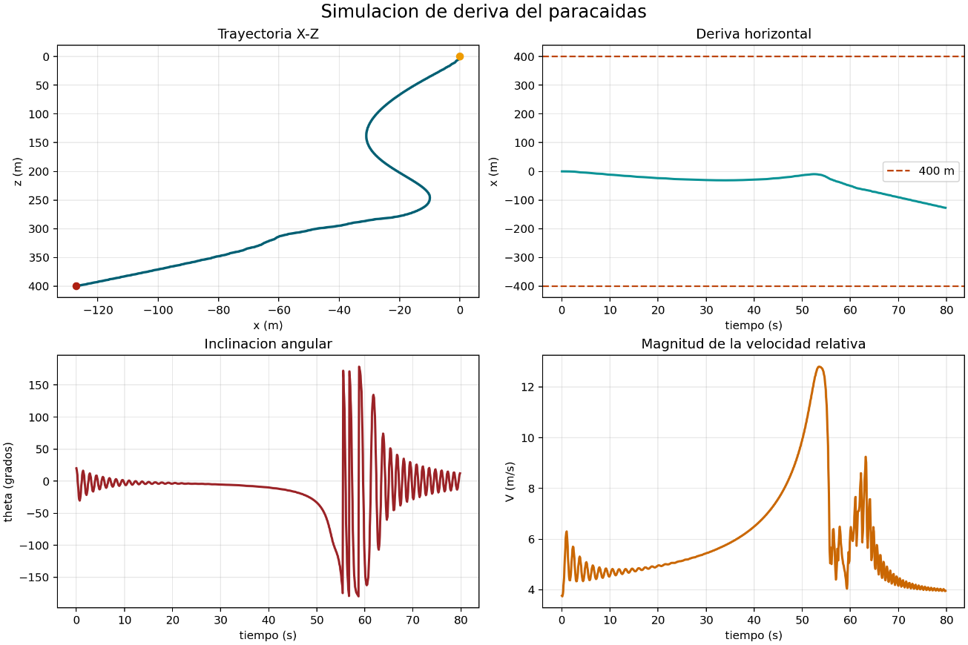
Based on these results, a maximum horizontal drift of 127,135 m was obtained, a value that is below the limit of 400 m considered as a safety criterion for the project. Therefore, according to the model used, the system complies with the established horizontal displacement constraint.
However, it is important to note that these results correspond to a preliminary numerical estimate, so it will be necessary to carry out future experimental tests to validate the real behavior of the system and contrast it with the model's predictions.

3.3 Electrical Power Subsystems
Describe the power source:
- Battery selection, nominal voltage, chemistry, continuous current, instantaneous current (if applicable) and capacity.
- Explain how power will be controlled, e.g. an easily accessible external switch.
Provide a high-level power budget estimate. As a guide, be sure to consider the following:
- Power consumption (Wh) of all components.
- Expected duty cycles for all components
- Source/uncertainty for each line item
- Total power consumed (Wh)
- Power sources and total power available.
Note: We suggest ensuring that power systems will work for a minimum of 45 minutes (please keep in mind that in most cases, recovery will take much longer than 45 minutes).

3.4 Category Challenge Integration
The payload’s primary purpose is to acquire, store, and transmit high-quality telemetry during ascent and descent, complying with Category 1: Launch a rocket with a CanSat as close to 450 km as possible. It incorporates all required standard sensors (altimeter and GPS) and adds an innovative hot-wire anemometer on the Ground Control System. In line with the Mach-26 Guidelines (exotopic, 2026, p. 9), the payload also records video throughout the flight, as a challenge. By combining redundant telemetry, local SD storage, and cloud backup, the system guarantees that all mission data will be recovered and analyzed, directly supporting both scoring and safety objectives.The following components and modules are part of the payload:
- Altimeter: GY-91 module (MPU9250 9-DOF IMU + BMP280 barometer). Dimensions: 25 × 14 × 3 mm. Operates at 3–5 V via I2C. Provides pressure (300–1100 hPa, resolution 0.16 Pa), temperature (±1 °C), and 9-DOF inertial data (InvenSense, 2016; Bosch, 2015; Naylamp Mechatronics, 2023).
- GPS: GT-U7 module. Dimensions: 16 × 12.2 × 2.4 mm. UART interface, 3.1–3.6 V. Supplies latitude, longitude, altitude, time, and satellite count (Goouuu Tech, n.d.).
- Innovation – Wind sensor: Anemometer Rev. C (hot-wire). Dimensions: 17.2 × 40.386 × 6.36 mm. Operates at 5 V, 20–40 mA. Measures 0–60 mph using constant-temperature hot-wire method; highly sensitive to light gusts at 18–24 inches (Modern Device, 2026).
- Microcontroller: ESP32-S3-DevKitC-1 (dual-core 240 MHz, 44 GPIO, I2C/SPI/UART, 16 MB Flash).
- Telemetry: RYLR998 LoRa (primary) + XBee 2.4 GHz (secondary)
- Storage: Micro-SD card module (backup).
- Video recording: RunCam Split 3 Micro (proposed solution). HD 1080p video, autonomous operation (no programming required), 5 V supply, MOV format. Current draw 200–400 mA.
The entire electronic system, comprising sensors, radio frequency modules, storage modules, and a camera, is controlled by the ESP32 microcontroller. Therefore, the primary programming stack is the Espressif ESP-IDF program. Because it is programmed in C, it allows for the implementation of serial communication configurations (SPI, I2C, UART) with complete freedom to modify interfaces to meet user needs. It also allows the use of FreeRTOS to assign order, priority, and speed to tasks, provides a high level of modification and configuration of low-level configuration parameters in the modules, and enables the creation of custom component libraries to optimize resources, initialize them, and operate them according to the requirements of the call for proposals and the IR2030 regulations. Furthermore, it eliminates dependence on other pre-established libraries (or those with limited parameters) that may change over time or restrict configuration customization to some extent.

On the ground side, our team implemented a full-stack telemetry infrastructure. The local ground station (desktop application) was built with Electron and Node.js as the backend. We use the serialport library to communicate with the ESP32 receiver through the serial port, chart.js to generate real-time graphs of all sensor data, and IPC (Inter-Process Communication) to manage smooth data flow between the different tabs of the interface (dashboard, map, and 3D model).
The web dashboard (remote monitoring platform) uses the same chart.js library for consistent graphing, Three.js together with GLTFLoader to render a realistic 3D model of the CanSat (loaded from a .glb file), and is fully deployed on Cloudflare Pages. The backend API is hosted on Cloudflare Workers, where we use the native fetch API to handle GET and POST requests between the local station and the cloud. Finally, all telemetry is persistently stored in a SQLite database through Cloudflare D1, ensuring that data remains available even if the local application is closed.

The following is the detailed pre-launch action plan that our team will execute on the day of the official launch at Machrihanish. This sequence ensures that the payload is fully functional, calibrated, and ready before it is inserted into the launch vehicle. All steps are performed in the preparation area with at least two team members present for cross-checking.

Payload visual and mechanical inspection (T-3 h)
- Inspect the CanSat for physical damage, loose screws, or misaligned components.
- Verify that the anemometer ports are clear and the RunCam lens is clean.
- Confirm that the external power switch is in the OFF position and the SD card is properly seated.
Acceptance: No visible damage; all connectors secure.

Power system verification (T-2.5 h)
- Measure battery voltage with a multimeter.
- Connect the payload to the external power switch and confirm that all subsystems power up correctly (LED indicators on module are a good indicator).
- Run a 5-minute idle test to confirm total current draw is within the power budget.
Acceptance: Voltage ≥ 5.0 V, 3.3 V in all critical components and current draw ≤ 350 mA.

Firmware upload and functional test (T-2 h)
- Upload the latest firmware version via USB.
- Verify that the ESP32 boots correctly and all sensors initialise (GY-91, GT-U7, RevC, LoRa, XBee, SD card and RunCam).
- Perform a 10-minute continuous data-logging test: confirm that telemetry packets are generated every 3 seconds (or new cycle duty timelapse) and saved to SD card.
Acceptance: No boot errors and all sensors report valid data.

Sensor calibration and ground reference (T-1.5 h)
- Place the CanSat at the launch site and record, at least, 10 ground-level readings for BMP280 for setting P₀ reference and GPS lock.
- Calibrate the RevC against a handheld wind meter (must read within ±0.5 mph).
- Confirm GPS achieves ≤ 4 m horizontal accuracy.
Acceptance: P₀ stable (accuracy on altitude over ground), GPS locked, anemometer working.

Radio range and redundancy test (T-1 h)
- Perform a 150 m line-of-sight range test using both LoRa (869.5 MHz) and XBee (2.4 GHz) links.
- Verify packet reception rate ≥ 95 % at maximum distance.
- Confirm that the ground station (local Electron app + web dashboard) receives and displays all data correctly.
Acceptance: ≥ 95 % packet success on both links.

Video recording and synchronisation test (T-45 min)
- Start a 10-minute test recording with the RunCam Split 3 Micro.
- Verify that the video file is saved correctly to SD card and that telemetry timestamps match the video.
Acceptance: Video records at 1080p without interruption with timestamps align.

Final arming/disarming and integration test (T-15 min)
- Insert the CanSat into the launch-vehicle payload bay.
- Perform a full arm/disarm cycle using the external switch.
Acceptance: Payload remains powered and transmitted when armed.

This pre-launch sequence has been rehearsed during our ground tests and takes approximately 3 hours, leaving sufficient margin before the scheduled launch window for any inconvenience to need be solved.
The payload will be considered successful if the following metrics are satisfied:
- ≥ 95 % of telemetry packets successfully received via LoRa or XBee up to 450 m.
- Altitude measurement error ≤ 5 m compared with the launch-vehicle altimeter (verified by barometric formula).
- GPS fix achieved with horizontal accuracy ≤ 4 m.
- Minimum 5 minutes of continuous 1080p video recorded to SD card in MOV format (RunCam Split 3 Micro).
- All data (telemetry + video files) successfully recovered and viewable within 30 minutes after landing.
Finally, data will be recovered through three independent methods:
- First method: LoRa 869.5 MHz transmission to the ground station (local Electron app + web dashboard).
- Second method: XBee 2.4 GHz transmission to the ground station (local Electron app + web dashboard).
- Third method: Cloud backup visible on the website.
- Fourth method: Recovery data from the micro-SD.
All telemetry samples are automatically forwarded to a Cloudflare D1 database via the ground station Worker API, creating a persistent cloud backup. Video files will be copied from the SD card and uploaded to the same cloud repository as a backup of the file. The four-method approach should ensure 100 % data availability even in the event of a single-link failure.

3.5 Requirements
Functional Requirements
ID | Description | Justification | Verification Method
FUN-1 | Acquire altitude, GPS position, IMU data, wind speed and video continuously during flight. | Mandatory sensors and video recording required by Mach-26 Category 1 (exotopic, 2026, p. 9). | Test and Demonstration
FUN-2 | Transmit telemetry in real time using LoRa primary + XBee secondary as a links | Ensures reliable data delivery and fulfils the mandatory backup tracking system. | Test
FUN-3 | Store all telemetry and video data locally on Micro-SD card. | Provides tertiary data recovery in case of radio link failure. | Test
FUN-4 | Calculate and transmit altitude using barometric formula in real time. | Required for accurate apogee detection and drift analysis. | Analysis and test

Performance Requirements
ID | Description | Justification | Verification Method
PER-1 | Achieve ≥ 95 % successful packet reception up to 450 m altitude. | Guarantees reliable real-time telemetry for scoring and safety monitoring. | Analysis and test
PER-2 | Maintain GPS horizontal accuracy ≤ 4 m. | Required for precise drift calculation and landing position. | Test
PER-3 | Record minimum 5 minutes of continuous 1080p video to SD card. | Satisfies the Category 1 video recording challenge. | Test
PER-4 | Transmit wind-speed data (0–60 mph) with update rate of at least 2 seconds. | Innovation requirement and scientific value of the anemometer. | Test

Design Requirements
ID | Description | Justification | Verification Method
DES-1

Interface Requirements
ID | Description | Justification | Verification Method
INT-1 | All sensors communicate with ESP32-S3 via standard protocols (I2C, UART, SPI). | Guarantees reliable and modular integration of GY-91, GT-U7, anemometer and LoRa. | Test
INT-2 | External power switch allows safe arming/disarming without opening CanSat. | Required for safe operations on the launch pad. | Demostration
INT-3 | Telemetry data format compatible with both local Electron station and web dashboard. | Enables seamless real-time display and cloud backup. | Test

Operational Requirements
ID | Description | Justification | Verification Method
OP-1 | Payload must be fully testable and armable within 3 hours prior to launch. | Matches the pre-launch testing plan (Section 3.4). | Demostration
OP-2 | SD card and video card must be easily removable after landing. | Allows rapid data recovery by the recovery team. | Demostration

Additional Requirements
ID | Description | Justification | Verification Method
ADD-1 | Provide cloud backup of all telemetry via Cloudflare D1. | Adds robustness and allows remote monitoring by judges and team. | Test
ADD-2 | Operate reliably in Machrihanish wind and rain conditions. | Ensures functionality under expected launch-site weather. | Test

4. Testing (5 pages)
Include detail on how you plan to test the following. Include the status of testing to show where this may have already been completed. PLEASE NOTE: Don’t underestimate the risks of electronic or electrical issues as this is what causes most of the delays in previous competitions. Make sure that you have planned in tests to make sure your electronics will work on the day!

4.1 Airframe Tests

The objective of the airframe testing campaign is to validate the structural integrity of the launch vehicle under expected aerodynamic and mechanical loads experienced during ascent and recovery.

4.1.1 Structural Load Testing
A static load test will be conducted to validate the structural resistance of the airframe and fin assembly under equivalent aerodynamic loading conditions.
Methodology:
- Apply distributed loads on the fin surfaces equivalent to calculated Max-Q conditions (~6500 Pa from Section 2.3)
- Apply bending loads at the fin root to simulate aerodynamic moments
- Measure deformation and check for structural failure
Objective:
- Verify compliance with DES-1 and DES-3 requirements
- Ensure no permanent deformation or cracking occurs
4.1.2 Fin Strength and Flexural Testing
To validate the laminated cedar fin structure:
Method:
- Perform a 3-point bending test on representative fin samples
- Measure maximum load before failure
- Compare results with analytical predictions
Objective:
- Validate resistance to aeroelastic loads
- Confirm adequate stiffness to prevent flutter
4.1.3 Assembly Integrity Test
A full airframe inspection and fit-check will be conducted:
Method:
- Assemble full vehicle
- Verify alignment of fins, motor mount, and payload bay
- Check structural bonding and adhesive joints
Objective:
- Validate manufacturing quality
- Ensure compliance with interface requirements
4.2 Recovery Tests
The recovery system testing aims to validate reliable parachute deployment and safe descent behaviour under realistic conditions.
4.2.1 Parachute Deployment Test
Method:
- Ground-based ejection simulation using compressed air or test charge
- Validate nosecone separation and parachute extraction
Objective:
- Verify FUN-1 and INT-1 requirements
- Ensure no entanglement or deployment failure
4.2.2 Descent Rate Validation
Method:
- Drop test from elevated structure (≥ 10 m recommended)
- Measure descent velocity using video analysis
Objective:
- Validate analytical descent velocity (~10–12 m/s)
- Confirm compliance with PER-3 requirement
4.2.3 Shock Cord Load Test
Method:
- Apply tensile load equivalent to deployment shock
- Measure elongation and inspect for failure
Objective:
- Validate structural integrity of Kevlar cord
- Ensure resistance to early deployment loads (~12.1 m/s)

4.3 Payload Deployment Tests
4.4 Payload Ejection Tests
This testing phase focuses on validating the safe and reliable separation of the CanSat payload during the recovery event.
    - Ejection Separation Test
Method:
- Simulate ejection event using ground-based pressurisation
- Observe separation between airframe and CanSat.
Objective:
- Verify clean separation without collision or re-contact
- Validate compliance with FUN-1 requirement
    - Deployment Dynamics Test
Method:
- Record high-speed video of deployment
- Analyse trajectory and separation distance
Objective:
- Ensure both systems deploy independently
- Prevent parachute entanglement
4.4.3 Integrated Recovery Test
Method:
- Full system test including:
  - Ejection
  - Separation
  - Dual parachute deployment
Objective:
- Validate complete recovery sequence
- Identify system-level interactions

4.5 Payload Electronics Tests
4.6 Payload Recovery Tests
4.7 Any other tests specific to your CanSat and/or Launch Vehicle.
4.7.1 Ground Station Local Software Integration Tests
This testing phase focuses on validating the reception, parsing, visualisation and local persistence behaviour of the desktop ground station when connected to the ESP receiver.
Method:
Connect the ESP-based receiver to the laptop through the operational USB serial interface
Transmit representative telemetry packets through LoRa and XBee so that the ESP forwards them through the same serial channel
Verify that the Electron ground station identifies the selected port, parses incoming messages and updates the dashboard, map and 3D view correctly
Generate a local report and confirm that the received telemetry is included in the exported files
Objective:
Validate that the local ground station software can operate as the primary mission interface without manual intervention
Confirm that telemetry reception from the ESP concentrator is compatible with the parser implemented in the station
Status: In progress. Parser compatibility tests have already been implemented in software and real serial integration tests are planned with the flight hardware.
4.7.2 Telemetry Parser and Serial Interface Tests
Method:
Execute automated parser tests using tagged messages such as [LORA] LAT:...,LON:... and [XBEE] LAT:...,LON:...
Test mixed messages containing TX, RX and distance information to validate transmitter-receiver separation calculations
Inject invalid or noisy log lines to confirm that the station ignores non-telemetry serial output
Objective:
Validate that the ground station can safely process partial telemetry during the current project phase
Ensure future compatibility with complete tagged telemetry once all payload magnitudes are transmitted
Status: Completed at software level. Automated parser tests currently pass for LoRa, XBee, TX/RX distance and legacy CSV formats.
4.7.3 Web Ground Station and Cloud API Tests
Method:
Send telemetry from the local ground station to the Cloudflare Worker using the operational HTTP endpoint
Query /api/health, /api/latest, /api/recent and /api/report to verify endpoint behaviour and response integrity
Open the web ground station from multiple clients and verify that dashboard plots, map trajectory, 3D model and report download update correctly
Objective:
Validate that the remote ground station reflects the same mission state as the local Electron station
Verify that the Worker API remains compatible with real-time visualisation and report export features
Status: Partially completed. Deployment, endpoint validation and web visualisation have already been verified. Multi-user operational tests remain pending.
4.7.4 Database Backup and Persistence Tests
Method:
Insert telemetry into the Worker API and confirm storage in the Cloudflare D1 database
Validate that the latest sample, recent history and downloadable reports remain available after multiple requests and session changes
Confirm that additional fields such as source channel, receiver coordinates and transmitter-receiver distance are persisted correctly
Objective:
Verify that the cloud backup system can preserve telemetry independently of the local desktop application state
Ensure that the remote web station always reads from a persistent and consistent data source
Status: Partially completed. D1 migrations and endpoint persistence were validated, but longer-duration mission tests remain to be completed.
4.7.5 End-to-End Redundancy and Communications Tests
Method:
Operate both LoRa and XBee links through the ESP receiver under field-like conditions
Compare whether the station continues to receive valid position information when one channel degrades or becomes intermittent
Measure whether the calculated distance, trajectory and speed remain coherent during handover or mixed reception conditions
Objective:
Validate the redundancy philosophy of the communications subsystem at the ground segment level
Demonstrate that the mission can continue receiving useful telemetry even if one wireless link becomes unreliable
Status: Planned. This test depends on integrated field trials with both radio modules operating simultaneously through the ESP receiver.

Be sure to reference the tests as you Include the results in the Appendix. We recommend looking at the required tests to perform, outlined in the Mach-26 Guidelines document.

5. Safety Management (3 pages)

5.1 Safety Compliance
Nuestra misión ha sido diseñada bajo un enfoque de ingeniería de sistemas que prioriza la integridad física y operativa, en estricto apego al Código de Seguridad de la UKRA y a las exigencias técnicas del comité organizador de Mach-26.
- Mach-26 Guidelines Requirement Compliance
- Propulsión y Categoría: Participamos en la Categoría 1 utilizando un motor sólido comercial (COTS) Aerotech G80-7T. Su impulso total se mantiene por debajo del límite máximo de 160 Ns establecido para esta clase.
- Integridad Estructural y Retenedor (ASA): El fuselaje principal está fabricado en cartón fenólico (papel kraft) de alta resistencia. El motor se asegura mediante un retenedor impreso en 3D utilizando filamento ASA (Acrilonitrilo Estireno Acrilato). Este material es óptimo para uso aeroespacial debido a su alta temperatura de deflexión térmica (HDT), lo que garantiza su integridad frente al calor irradiado por el motor. Mecánicamente, su alta tenacidad permite cumplir con el requisito de soportar y transmitir una fuerza equivalente a dos veces el empuje máximo del motor sin sufrir deformación permanente, superando además en durabilidad a otros polímeros ante la radiación UV y la humedad del entorno de vuelo.
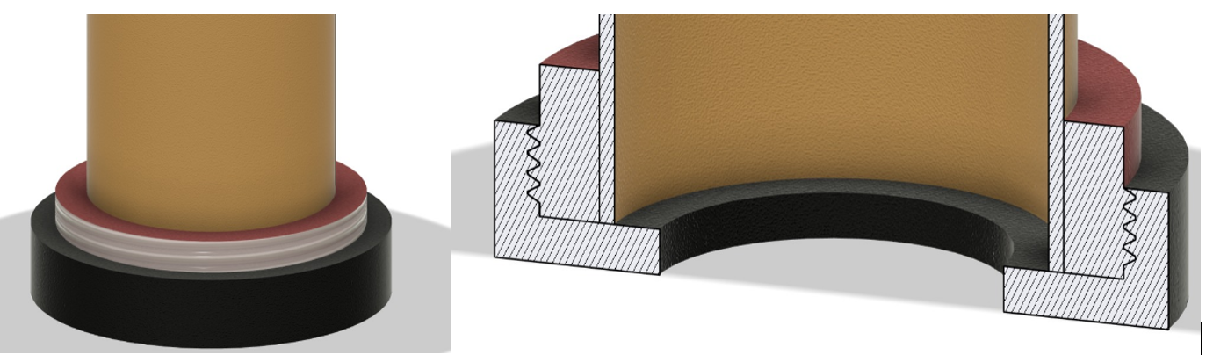
Figure 1: Retén de impresión 3D en filamento ASA para sostener el motor.
- Protocolo de Ignición y Seguridad en Rampa: Para evitar redundancias inseguras con los sistemas de la organización, el cohete no integra un cable pull-pin de desarmado de fabricación propia. En su lugar, el sistema depende íntegramente de los protocolos de lanzamiento del evento, utilizando el seguro de tres puntos operado exclusivamente por el Oficial de Seguridad de Campo (RSO).
- Sistema de Recuperación: La separación del cono y la eyección de la carga útil se realizan de forma mecánica mediante la carga de eyección secundaria del motor. Para prevenir quemaduras en el paracaídas y en la estructura por los gases de combustión, se utiliza una tela ignífuga envolvente.
- Rendimiento en Descenso y Medición de Altitud: Se ha validado mediante cálculos una velocidad de aterrizaje vertical de 12 m/s, lo que cumple con el requisito de mantener la velocidad por debajo de los 15 m/s. Para cumplir con el registro obligatorio del apogeo (~450m), nuestro diseño aprovecha la aviónica del CanSat. Se emplea el módulo GY-91, que integra un barómetro BMP280 de alta precision . Los datos telemétricos recopilados durante el ascenso, hasta la eyección mecánica, proporcionarán la lectura oficial de la misión.
- Rastreo Redundante y Desafío de Video: El CanSat cuenta con una arquitectura de telemetría de doble vía altamente robusta, operada por un microcontrolador ESP32-S3. El enlace primario utiliza radiofrecuencia LoRa (RYLR998 a 869.5 MHz), mientras que el seguimiento de respaldo se realiza mediante el protocolo XBee 3 (2.4 GHz). El posicionamiento se obtiene vía un módulo GPS GT-U7 . Adicionalmente, para cumplir con el desafío de la categoría , el CanSat graba video en formato HD usando una RunCam Split 3 Micro, almacenando los datos localmente en una memoria SD sin saturar el ancho de banda de radiofrecuencia .
Nota sobre Rastreo Independiente y Acercamiento con el Comité: Debido a que nuestra secuencia de separación es puramente mecánica y se ha prescindido de una computadora de vuelo en el fuselaje para optimizar la masa, el cuerpo del cohete inicialmente depende del rastreo visual de su paracaídas. El CanSat cuenta con su propio sistema de GPS y telemetría para su localización autónoma. Nuestro equipo reconoce la regla que exige un sistema de localización de respaldo para el vehículo; por lo tanto, si tras la revisión técnica el comité determina que la inclusión de un sistema electrónico en el cohete es estrictamente necesaria y obligatoria, nos comprometemos a adaptar e integrar un módulo de rastreo autónomo (RF/GPS) antes de la revisión FRR.
- Team Requirement Compliance
El equipo opera bajo el límite de miembros establecido y cuenta con la supervisión de un contacto académico en nuestra universidad. Cada integrante asume responsabilidades claras y debe verificar la integridad de su respectivo subsistema antes de la inspección final de seguridad en el evento.

5.2 Risks and Mitigation
Nuestra evaluación de riesgos ha sido actualizada de forma exhaustiva desde la fase PDR, identificando posibles eventualidades y delineando responsabilidades claras para asegurar la misión.
ID | Risk | Impact | Probability | Severity | Mitigation
1 | Falla de ignición o retardo del motor. | Lanzamiento inestable o misión abortada. | Baja | Alta | Uso exclusivo de motor COTS certificado (Aerotech G80-7T). Verificación de continuidad en rampa y acato estricto a los protocolos de seguridad y autorización del RSO de Mach-26.
2 | Falla estructural del fuselaje, aletas o retenedor. | Pérdida del vehículo y generación de escombros peligrosos. | Baja | Alta | Uso de tubo de cartón reforzado (Apogee), aletas/anillos de madera de cedro y retenedor impreso en ASA. Inspecciones pre-lanzamiento y pruebas de carga estática para soportar 2x el empuje máximo.
3 | Malfuncionamiento del sistema de recuperación (falla de despliegue). | Aterrizaje brusco (>15 m/s), daño a la carga útil y al cohete. | Baja | Alta | Pruebas en tierra del despliegue con la carga de eyección del motor. Refuerzo de conexiones con cuerda de Kevlar para absorber impactos y uso de tela ignífuga.
4 | Falla en la separación del CanSat. | Pérdida de datos de la carga útil y descenso inseguro. | Baja | Media | Diseño de separación mecánica simple impulsado por los gases del motor. Múltiples pruebas de tolerancia (fit checks) y pruebas de despliegue en tierra.
5 | Falla del sistema de telemetría o rastreo. | Dificultad para localizar el CanSat tras el aterrizaje. | Media | Baja | Arquitectura de telemetría redundante (LoRa + XBee) y registro de datos a bordo mediante tarjeta SD. (Adaptación de módulo RF de respaldo en el cohete si es exigido).
6 | Condiciones meteorológicas adversas (viento, lluvia). | Deriva (drift) fuera de la zona de recuperación permitida (400m) o daño eléctrico. | Media | Media | Monitoreo climático previo al vuelo , encapsulamiento impermeable de la aviónica, y respeto a los criterios de aplazamiento de Mach-26 ante vientos fuertes.

Matriz de Modos de Fallo
Subsistema | Modo de Fallo | Efecto en la Misión | Medida Preventiva/Verificación
Fuselaje | Deformación del tubo de papel kraft por humedad o tensión térmica. | Inestabilidad aerodinámica y posible desviación de la trayectoria. | Tratamiento de la superficie con sellado fenólico; pruebas de rigidez estructural.
Recuperación | Ruptura o enredo de la cuerda de Kevlar. | Separación del cono y descenso inestable del cohete a gran velocidad. | Dimensionamiento para cargas de choque extremas; uso de eslabones giratorios (swivels) y protocolo de empaque.
Electrónica CanSat | Falla en sensores de presión o pérdida de señal de telemetría. | Incapacidad para registrar la altitud del apogeo y otros datos. | Pruebas de vibración en tierra y reforzamiento de conexiones/soldaduras con pegamento térmico.
Carga Útil | Atasco mecánico del CanSat dentro del fuselaje del cohete. | Falla en el despliegue del experimento y de los paracaídas. | Pulido del interior del tubo y realización de múltiples pruebas de ajuste mecánico (fit checks).
Despliegue | Separación prematura del cono durante el despegue. | Apertura anticipada del sistema de recuperación a velocidades críticas. | Implementación de pasadores de cizalla (shear pins) dimensionados para la presión interna de vuelo.

6.Project Management (3 pages)

6.1 Schedule
Update the Work Breakdown Structure and Gantt chart from the PDR. The Gantt chart should show task start and stop dates, durations and dependencies. Please include any concerns/delays you anticipate and how they might be tackled.
The updated Work Breakdown Structure and schedule for the final project phase run from 10 April to 1 June. The plan prioritises software integration, telemetry validation, remote monitoring deployment, redundancy testing and final system verification before mission closeout.
The following schedule summarises the main work packages, their start and finish dates, duration and principal dependencies.
Work Package | Start | Finish | Duration | Dependencies
Final design freeze and subsystem review | 10 Apr | 16 Apr | 7 days | PDR decisions and subsystem status
Ground station software integration | 14 Apr | 24 Apr | 11 days | Serial format definition and parser updates
Web ground station and backend deployment | 16 Apr | 26 Apr | 11 days | Worker, Pages and D1 configuration
Payload electronics and communications validation | 18 Apr | 30 Apr | 13 days | ESP receiver integration and radio availability
Recovery and deployment tests | 22 Apr | 4 May | 13 days | Mechanical assembly and recovery hardware readiness
Local and remote end-to-end testing | 28 Apr | 10 May | 13 days | Ground station plus cloud integration complete
Redundancy and stress testing | 8 May | 18 May | 11 days | LoRa and XBee simultaneous operation
Full mission simulation and validation | 15 May | 25 May | 11 days | Recovery, telemetry and dashboard validation
Documentation closeout and final review | 22 May | 1 Jun | 11 days | Completion of test evidence and final corrections
Key schedule concerns include possible delays in radio integration, unexpected serial-format mismatches, and reduced time for full end-to-end tests. These risks are mitigated by overlapping software and web development, maintaining parser-level automated tests, and reserving the final validation block exclusively for integrated mission rehearsals.

6.2 Budget
Provide an updated budget for your entry to the Mach-26 competition. The budget should contain the following:
- A summary of total expenditure and income.
- A detailed cost breakdown
- The status of procurement for each component.
- Sources of income.
Note that the cost breakdown needs to include the cost of components and hardware, as well as costs involved to participate in the event (e.g. travel to Glasgow, ground station, test facilities, etc). This does not need to include costs covered by entry/accommodation fees paid.

7. Conclusion (>1 page)
Provide a summary and conclusions. Outline your major accomplishments since the PDR. Are there any major unfinished work and detail plans as to how to resolve this.

8. Acknowledgements
Insert any acknowledgements in this section, or extra information that you wish to include.

Appendix

